Discover Udaipur with INTRO TRAVELS INDIA
Udaipur, famously known as the “City of Lakes,” is one of India’s most romantic and beautiful destinations. Located in the royal state of Rajasthan, Udaipur is famous for its majestic palaces, peaceful lakes, luxury heritage hotels, colorful culture, and breathtaking sunsets. Surrounded by the Aravalli Hills, the city offers a perfect blend of royal heritage, scenic beauty, and cultural richness.
Whether you are planning a honeymoon, family vacation, luxury getaway, or heritage tour, Udaipur promises a magical travel experience.

Why Visit Udaipur?
- Stunning lakes & sunset views
- Royal palaces & forts
- Luxury heritage hotels
- Romantic honeymoon destination
- Rich Rajasthani culture & traditions
- Beautiful temples & gardens
- Traditional shopping markets
- Perfect destination for photography

Top Tourist Attractions in Udaipur
1. City Palace
One of Rajasthan’s largest and most magnificent royal palace complexes.
Highlights:
- Royal architecture
- Courtyards & balconies
- Crystal Gallery
- Panoramic lake views
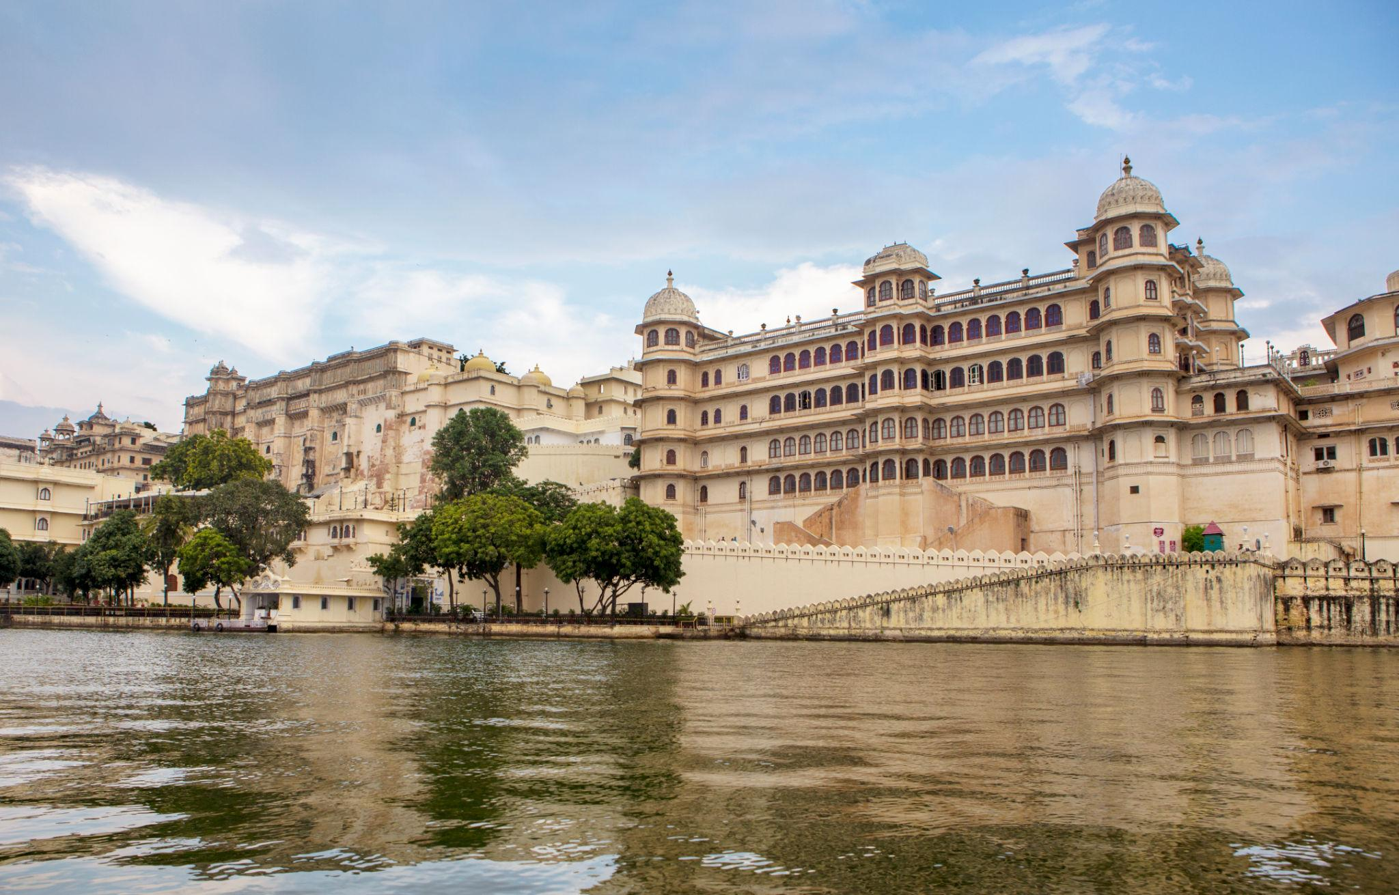
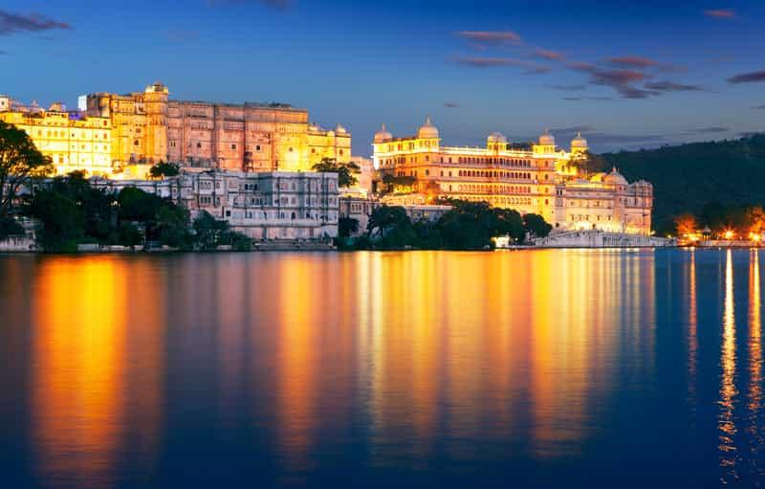
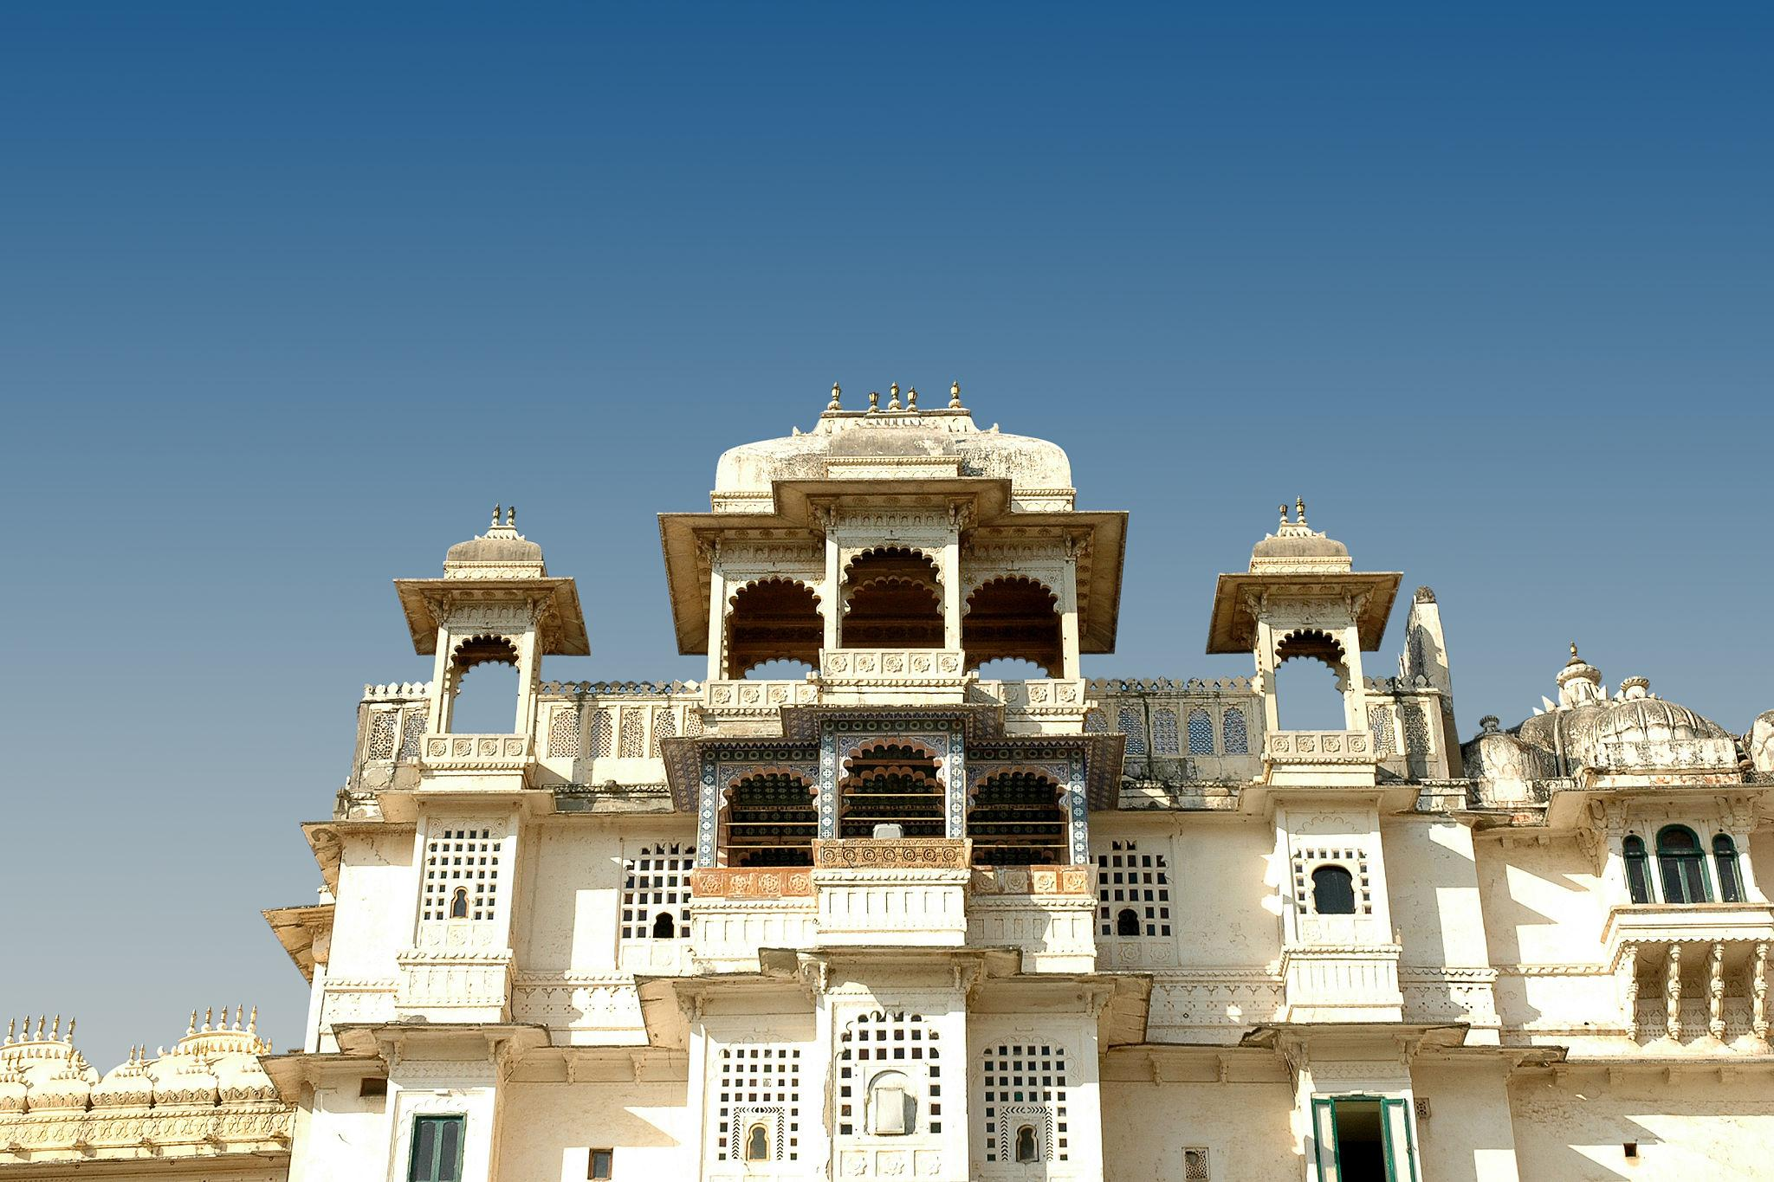
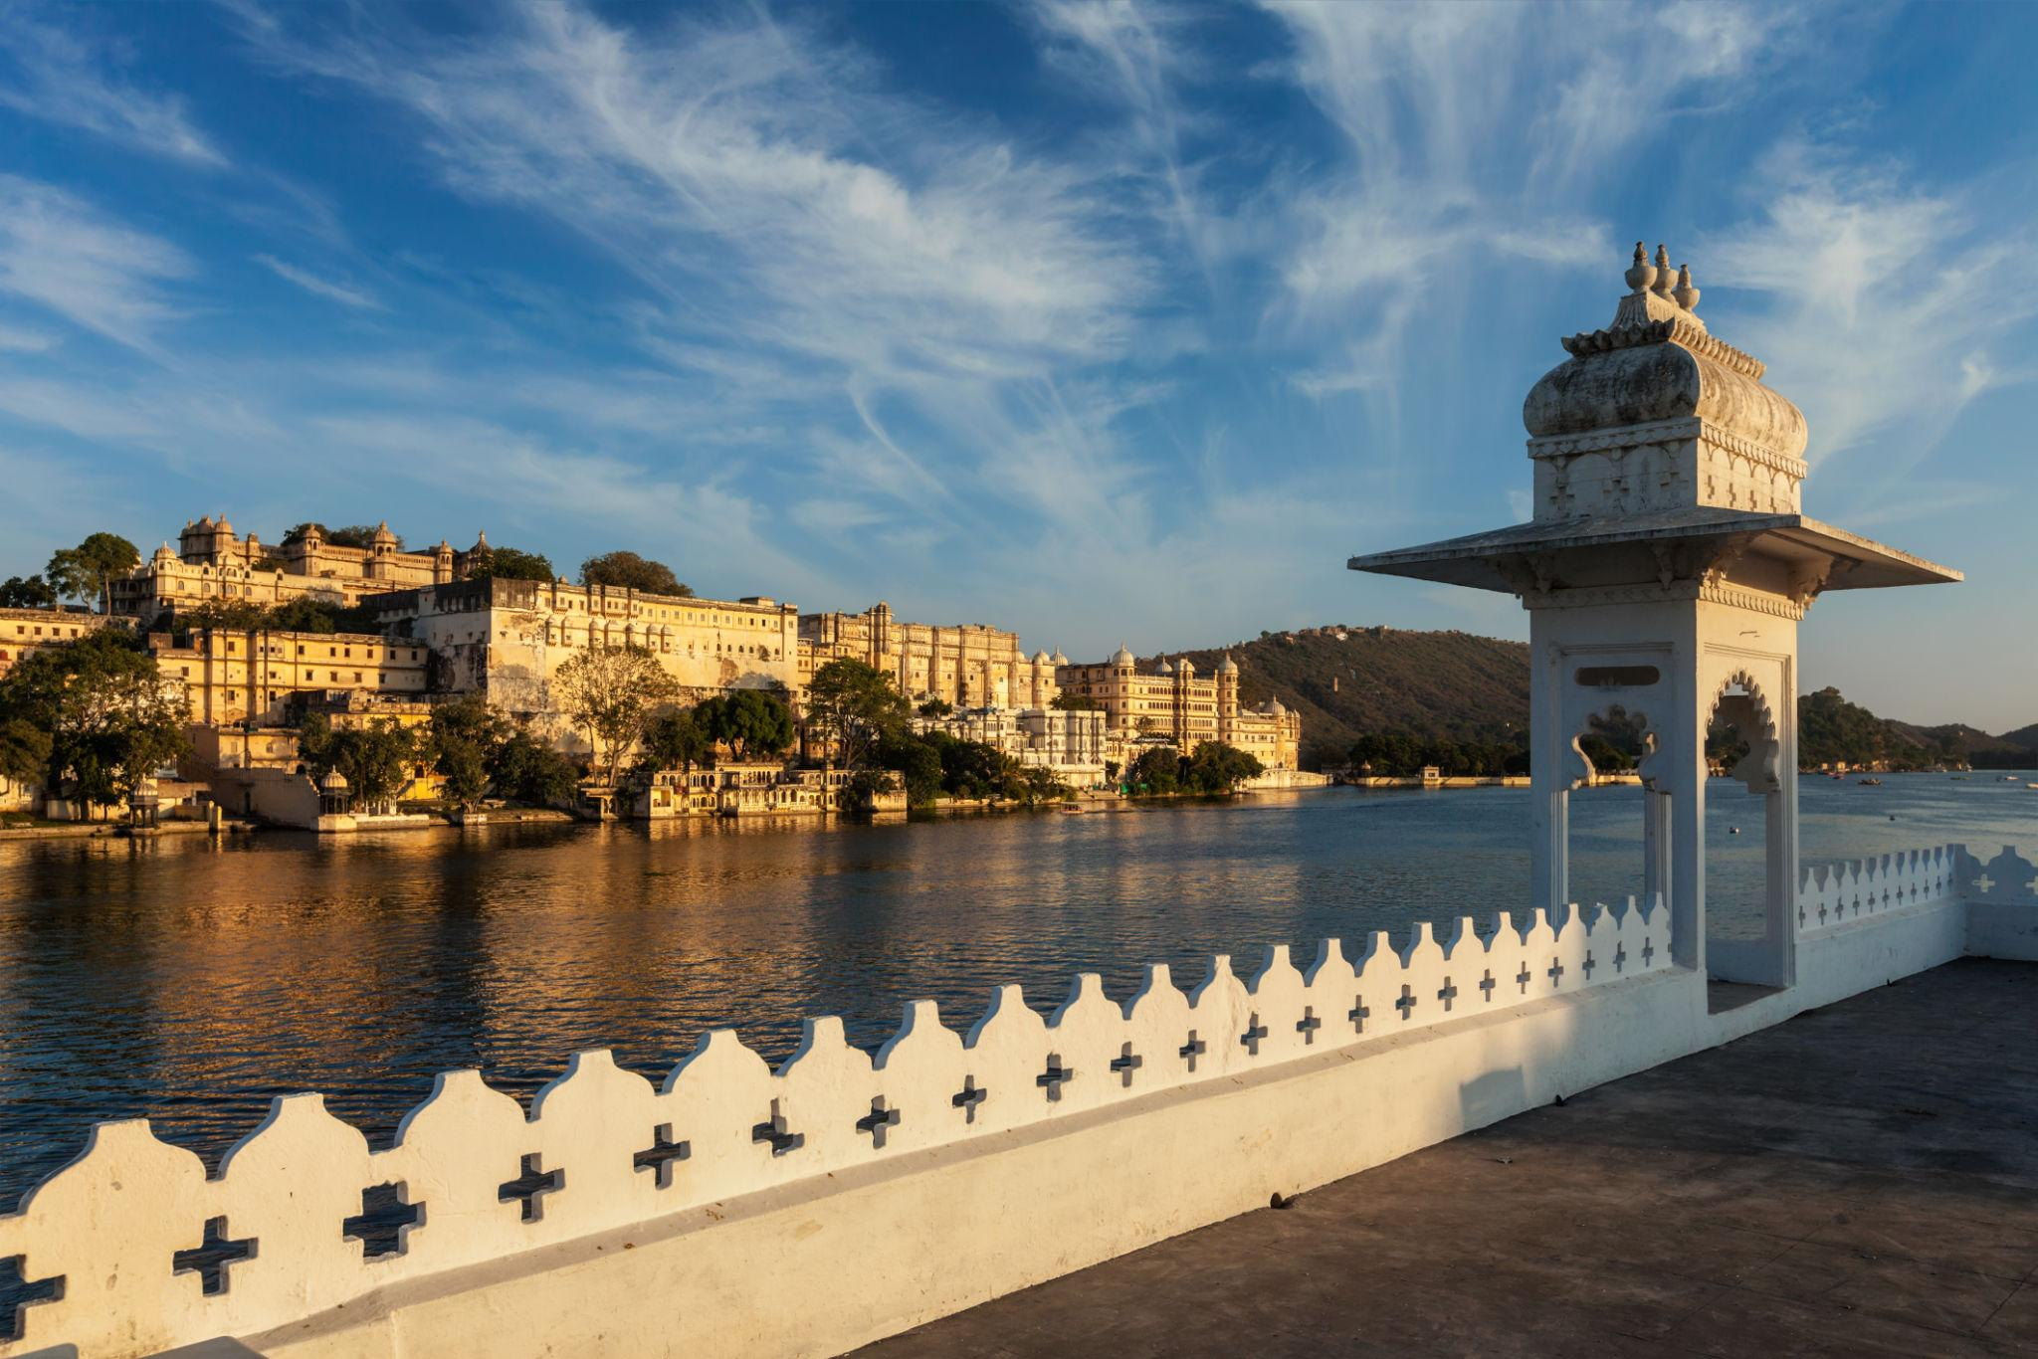
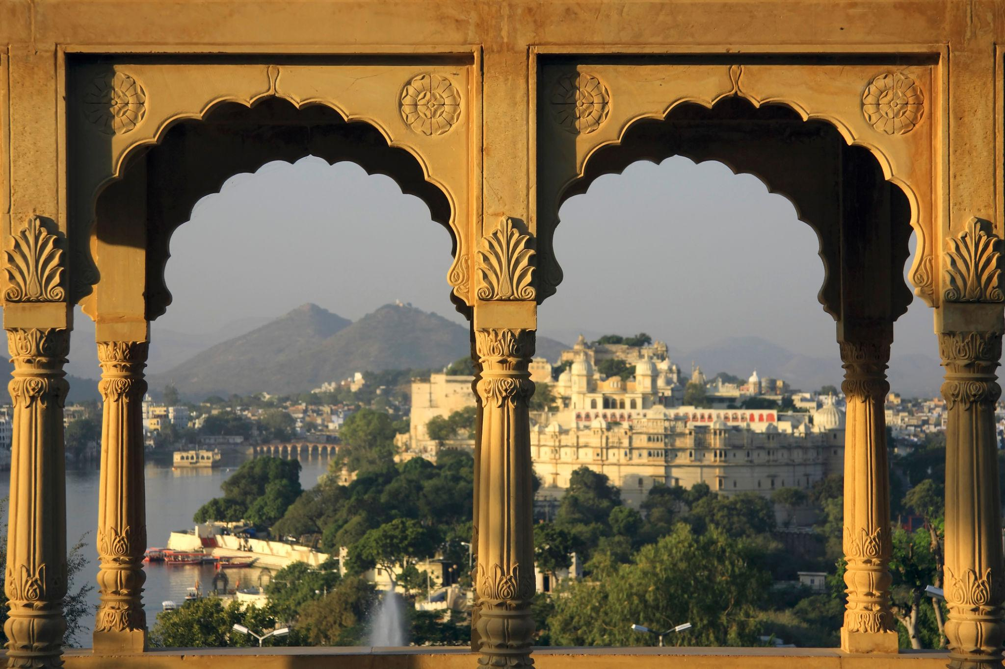
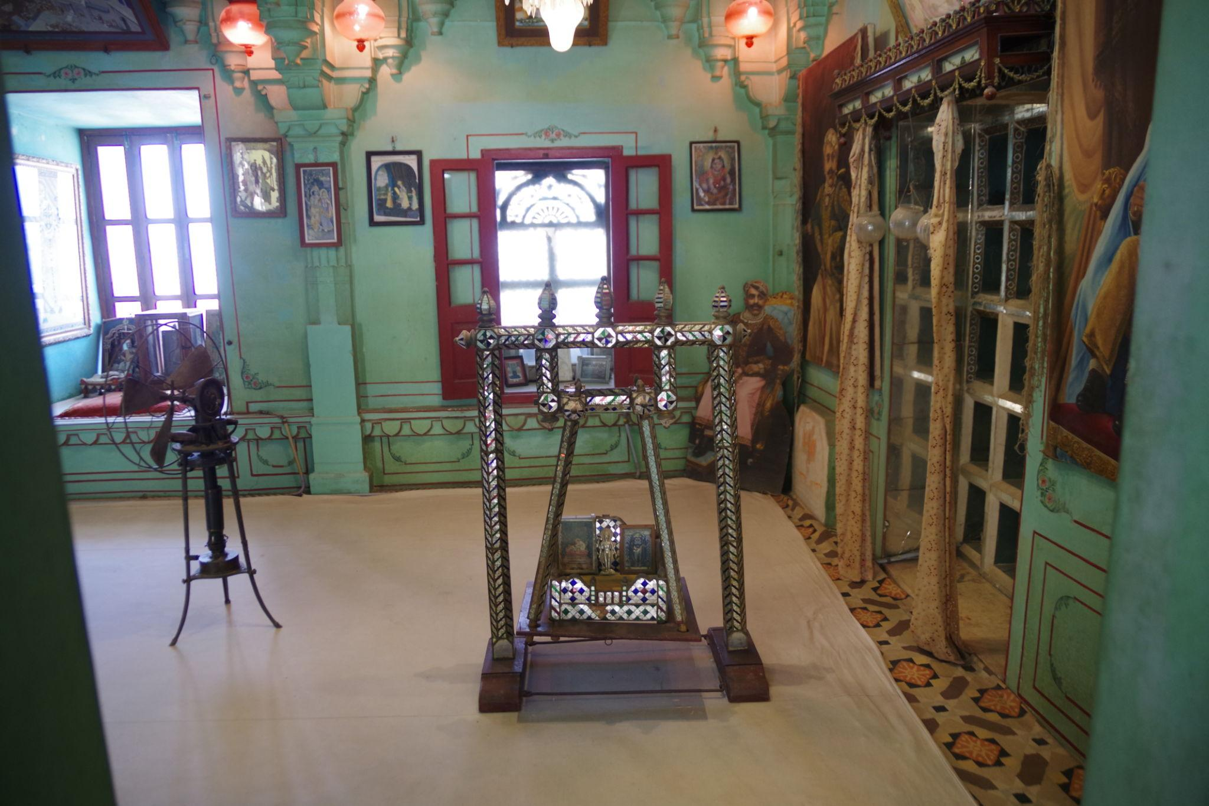
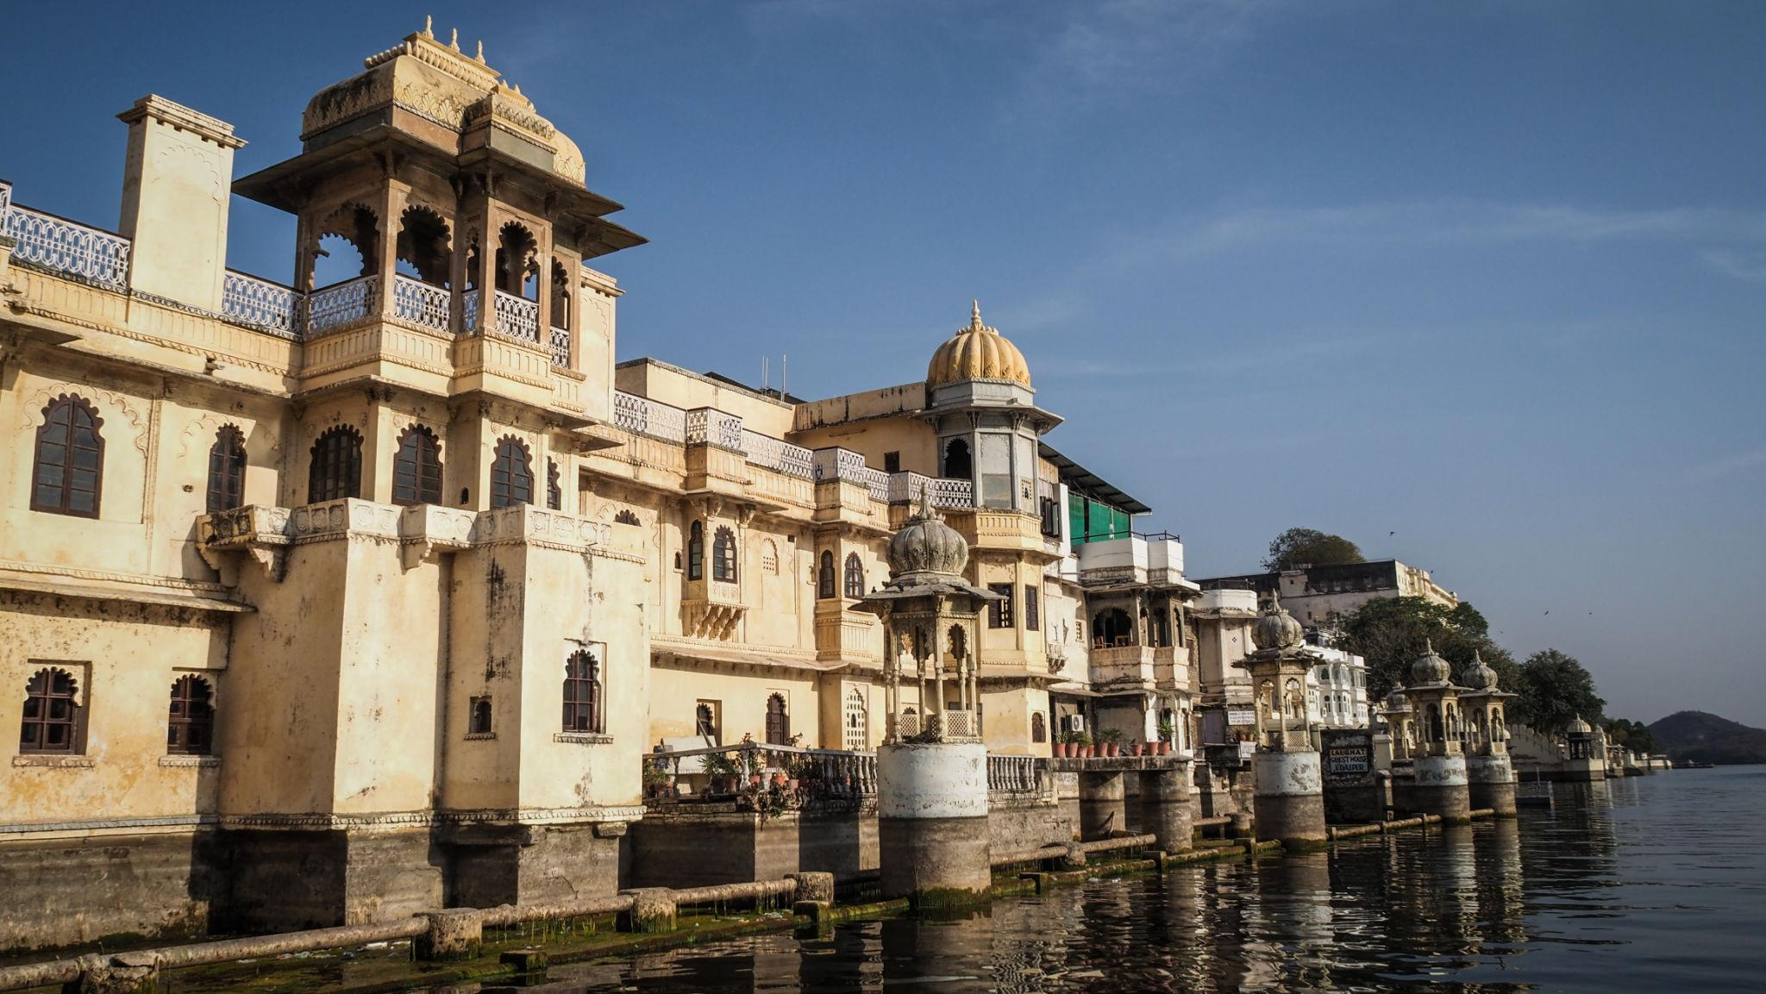

2. Lake Pichola
The most famous lake in Udaipur known for scenic boat rides and sunset views.
Best experiences:
- Boat cruises
- Sunset photography
- Lakefront dining
- Scenic palace views
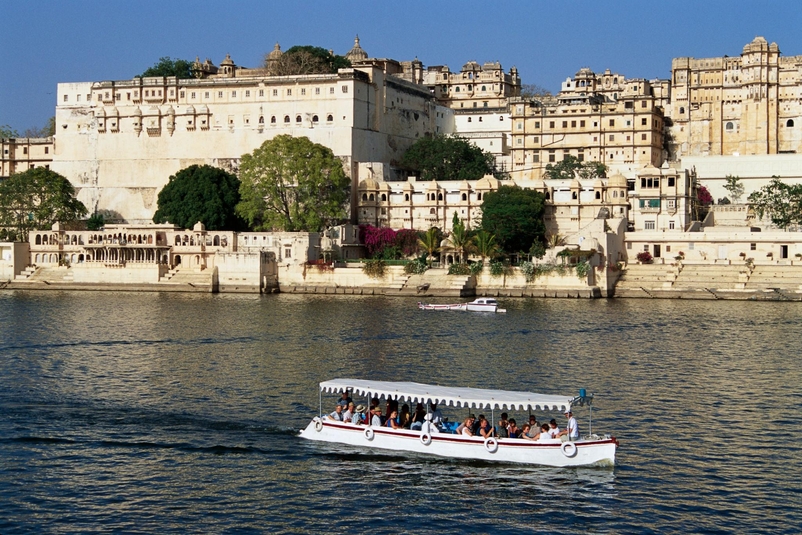
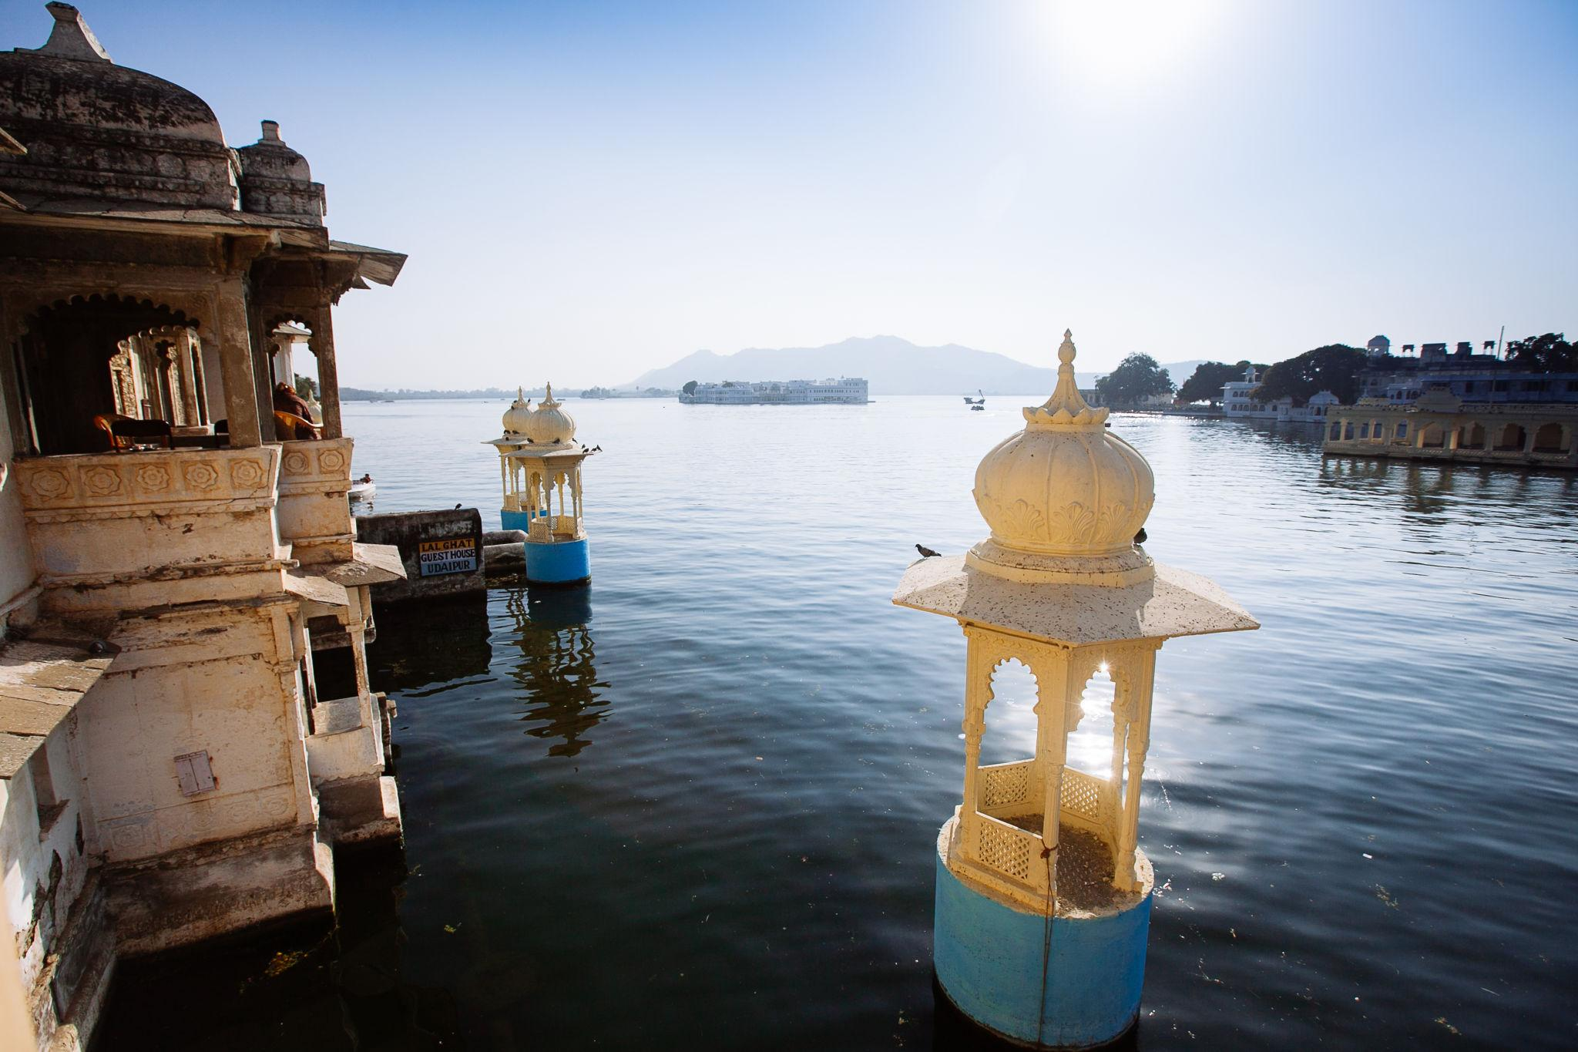
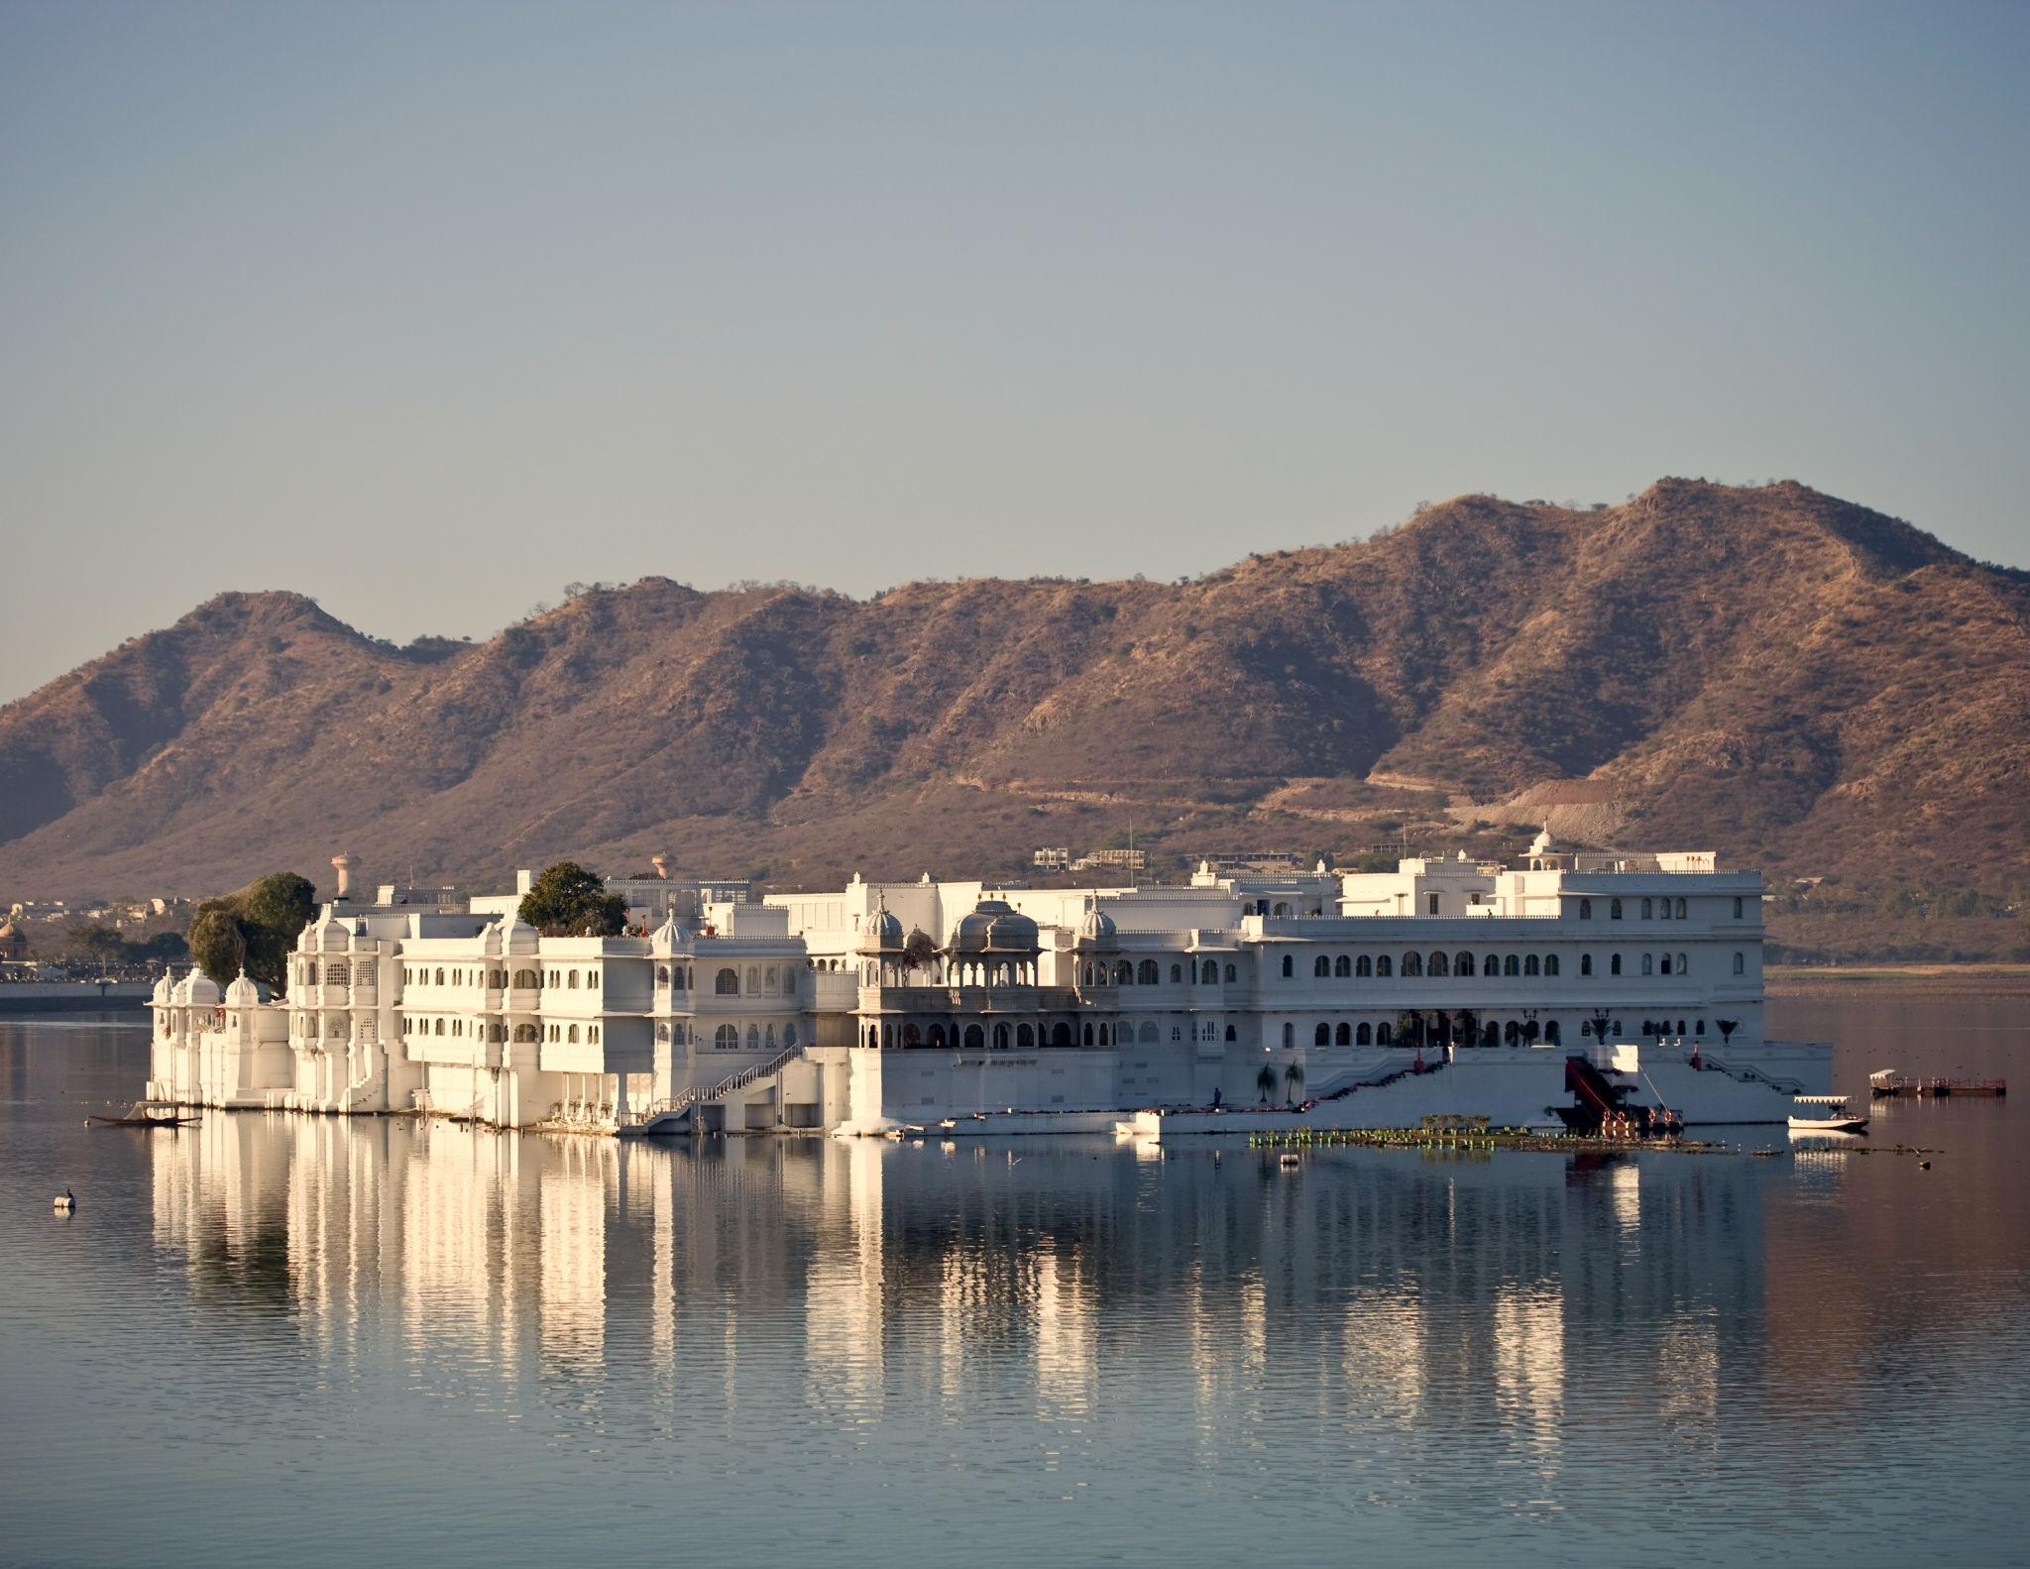
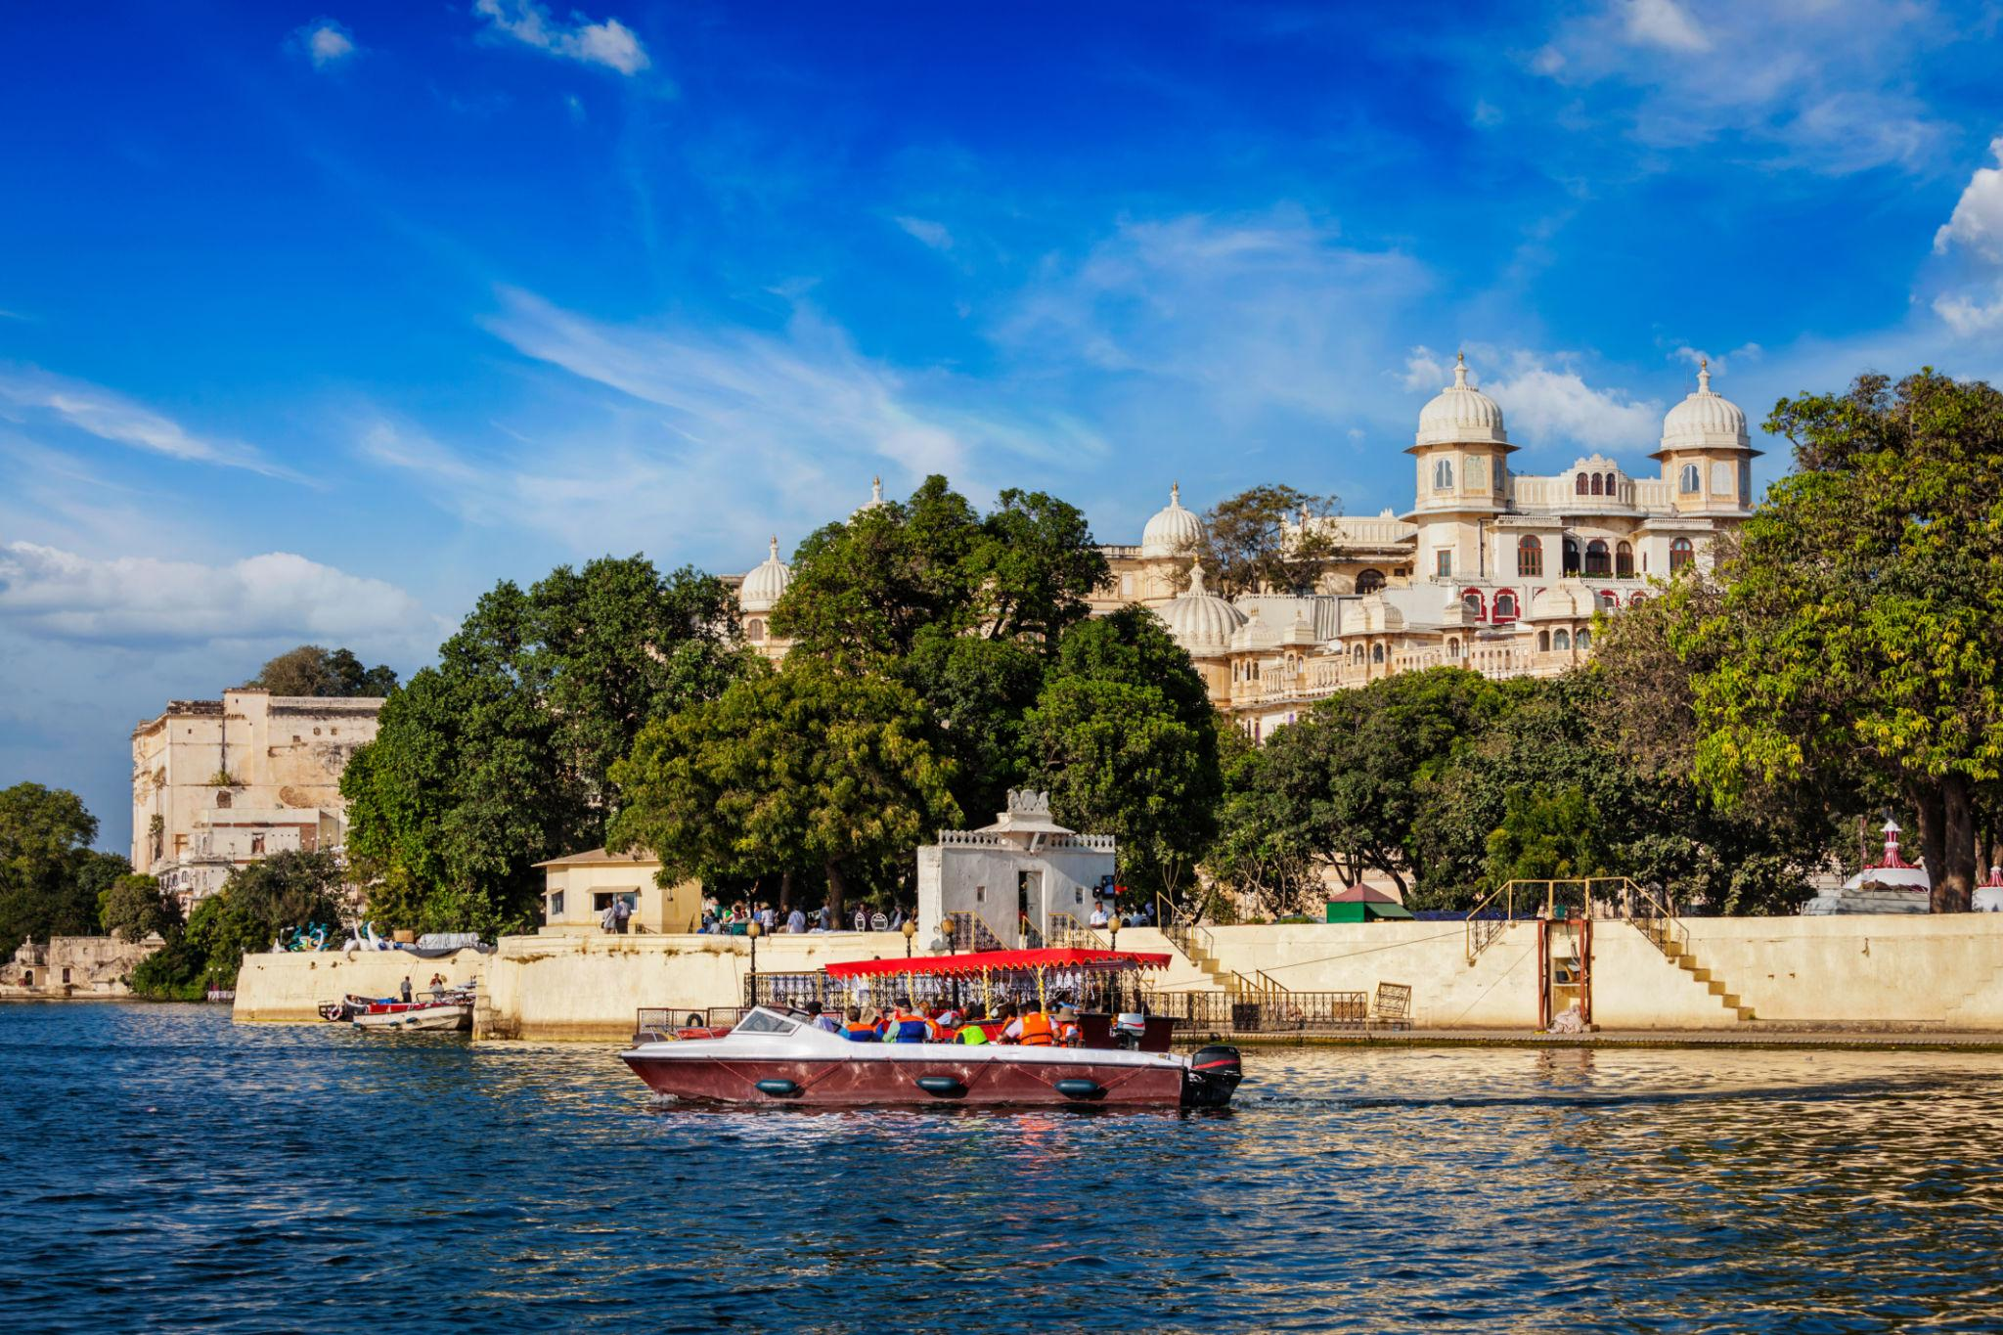
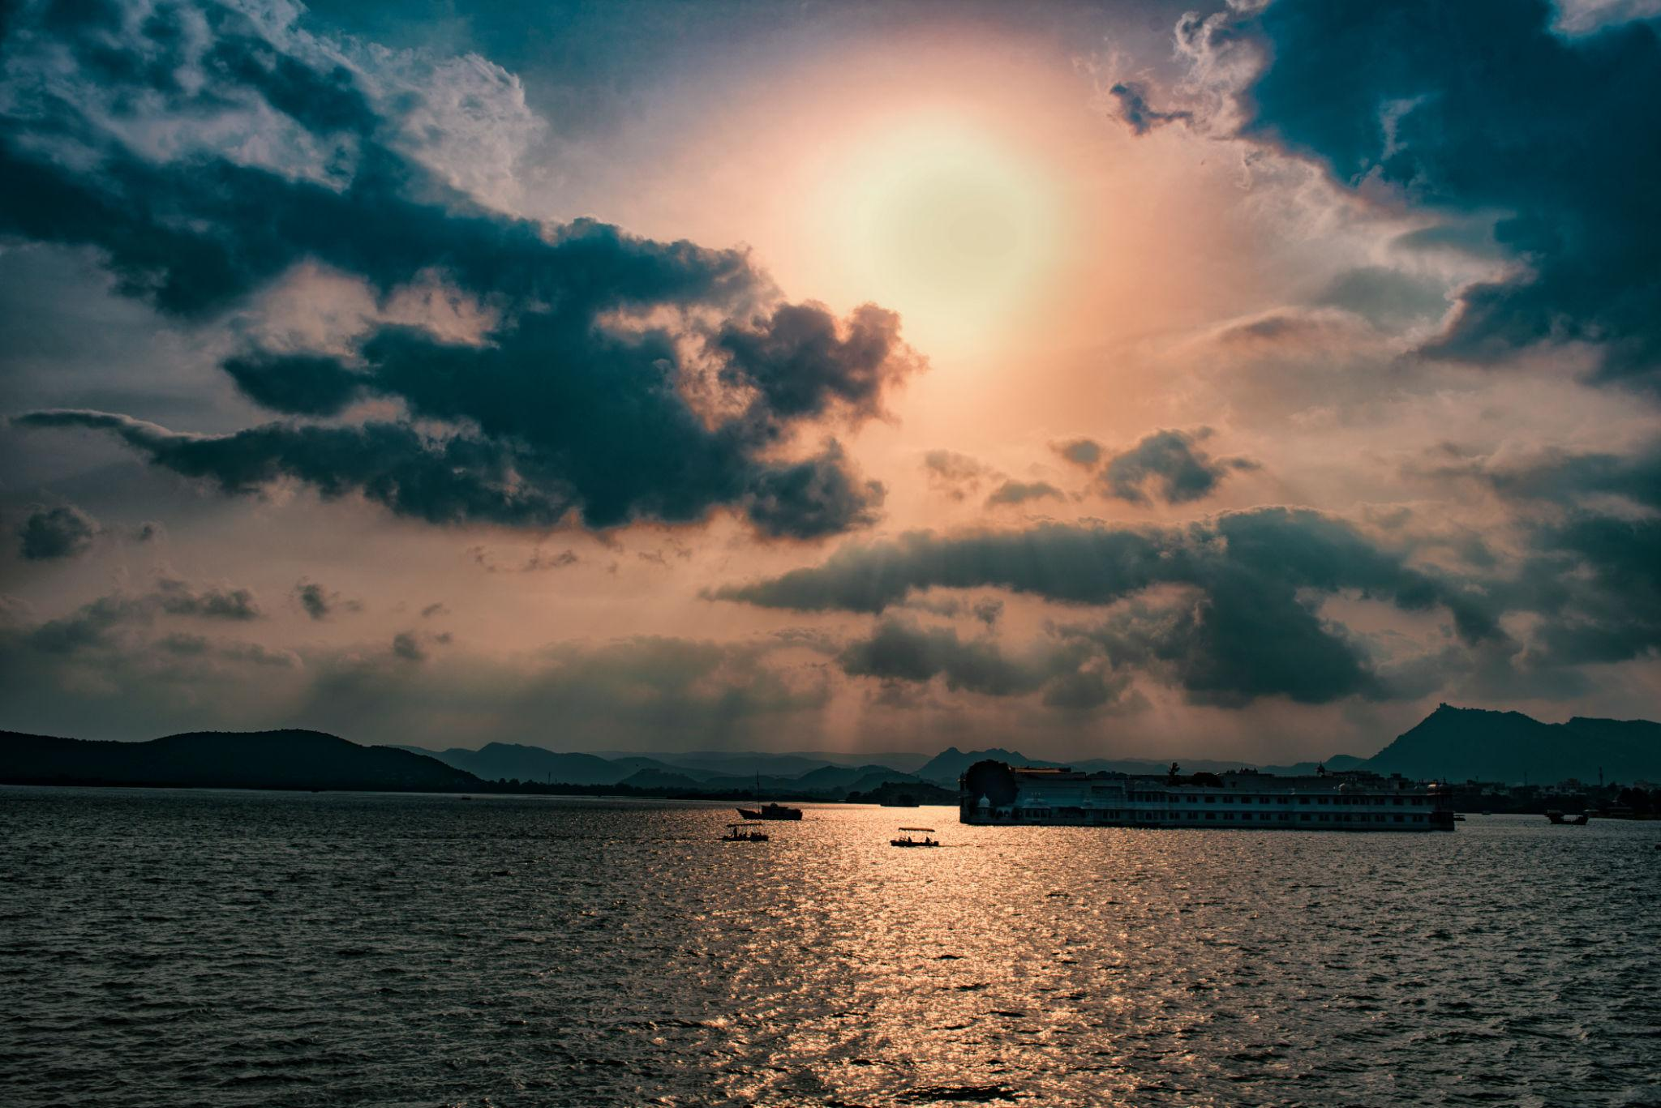
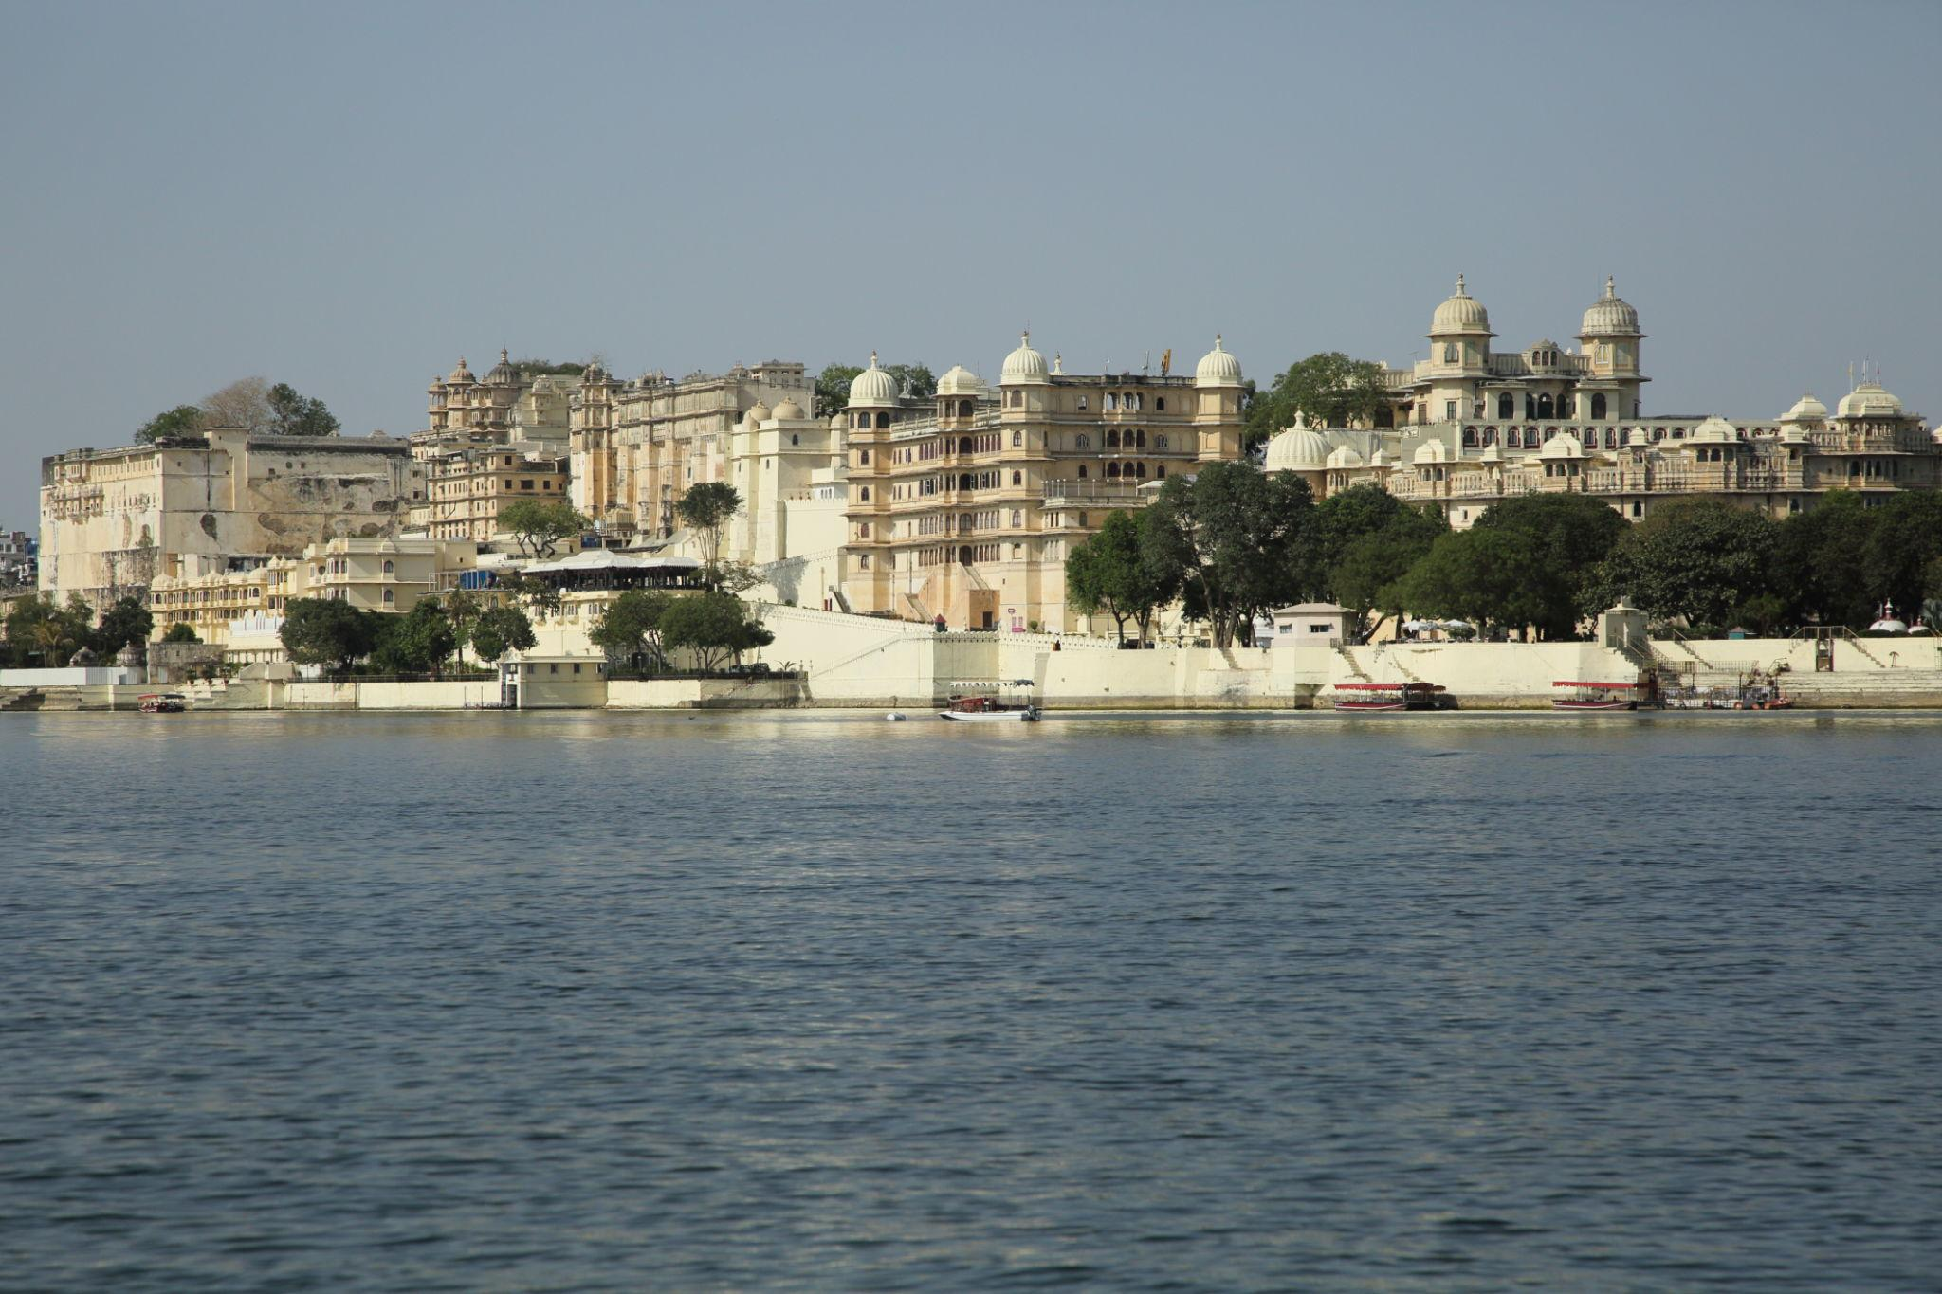

3. Jag Mandir
A beautiful island palace located on Lake Pichola.
Known for:
- Marble architecture
- Royal gardens
- Luxury dining experiences
- Historic royal charm
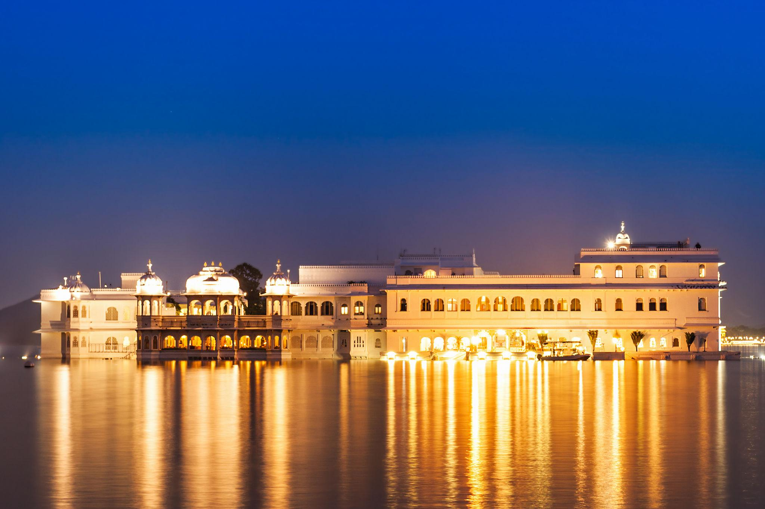
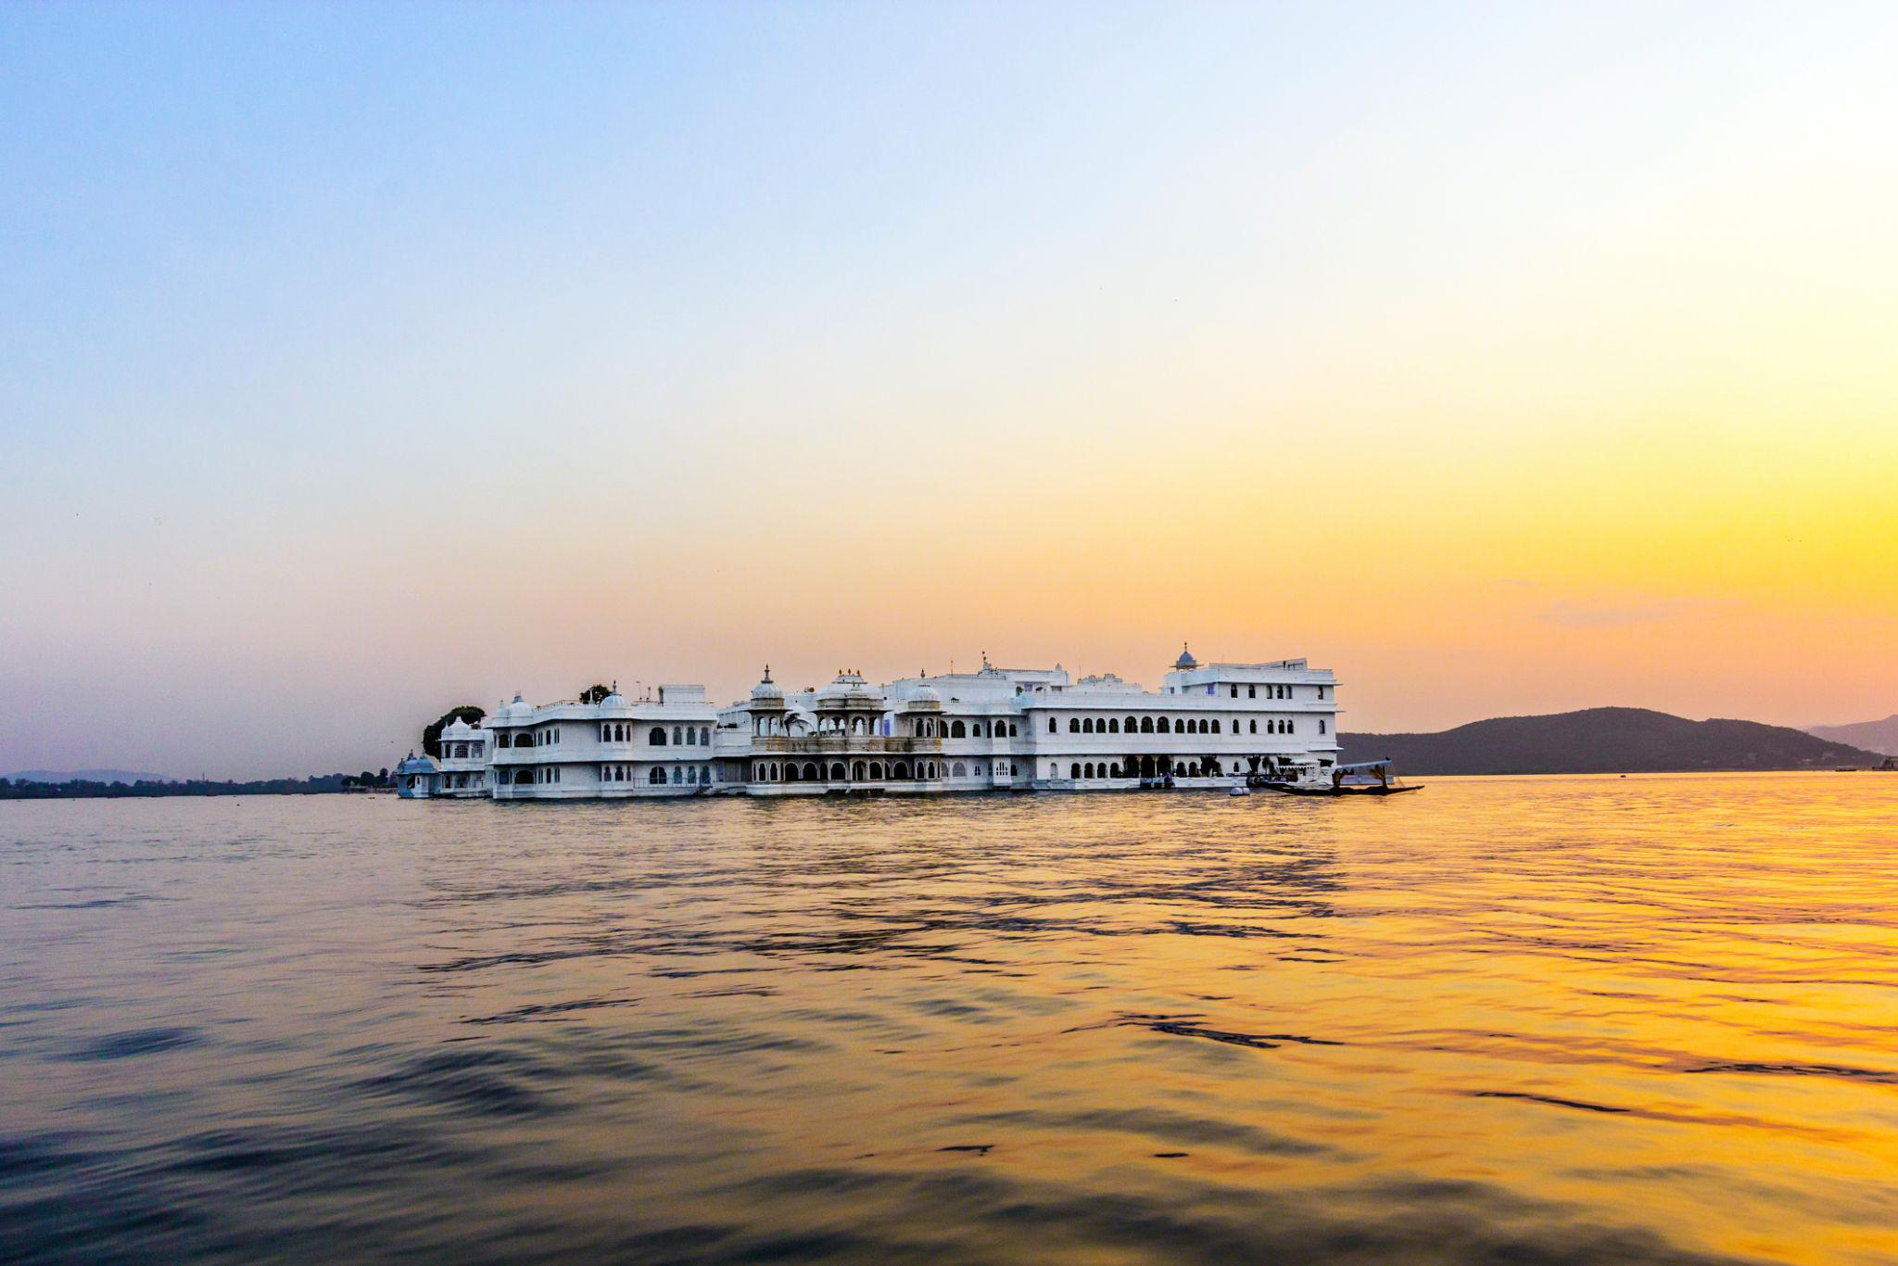
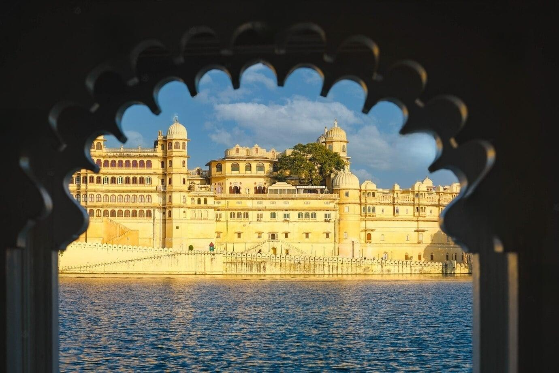
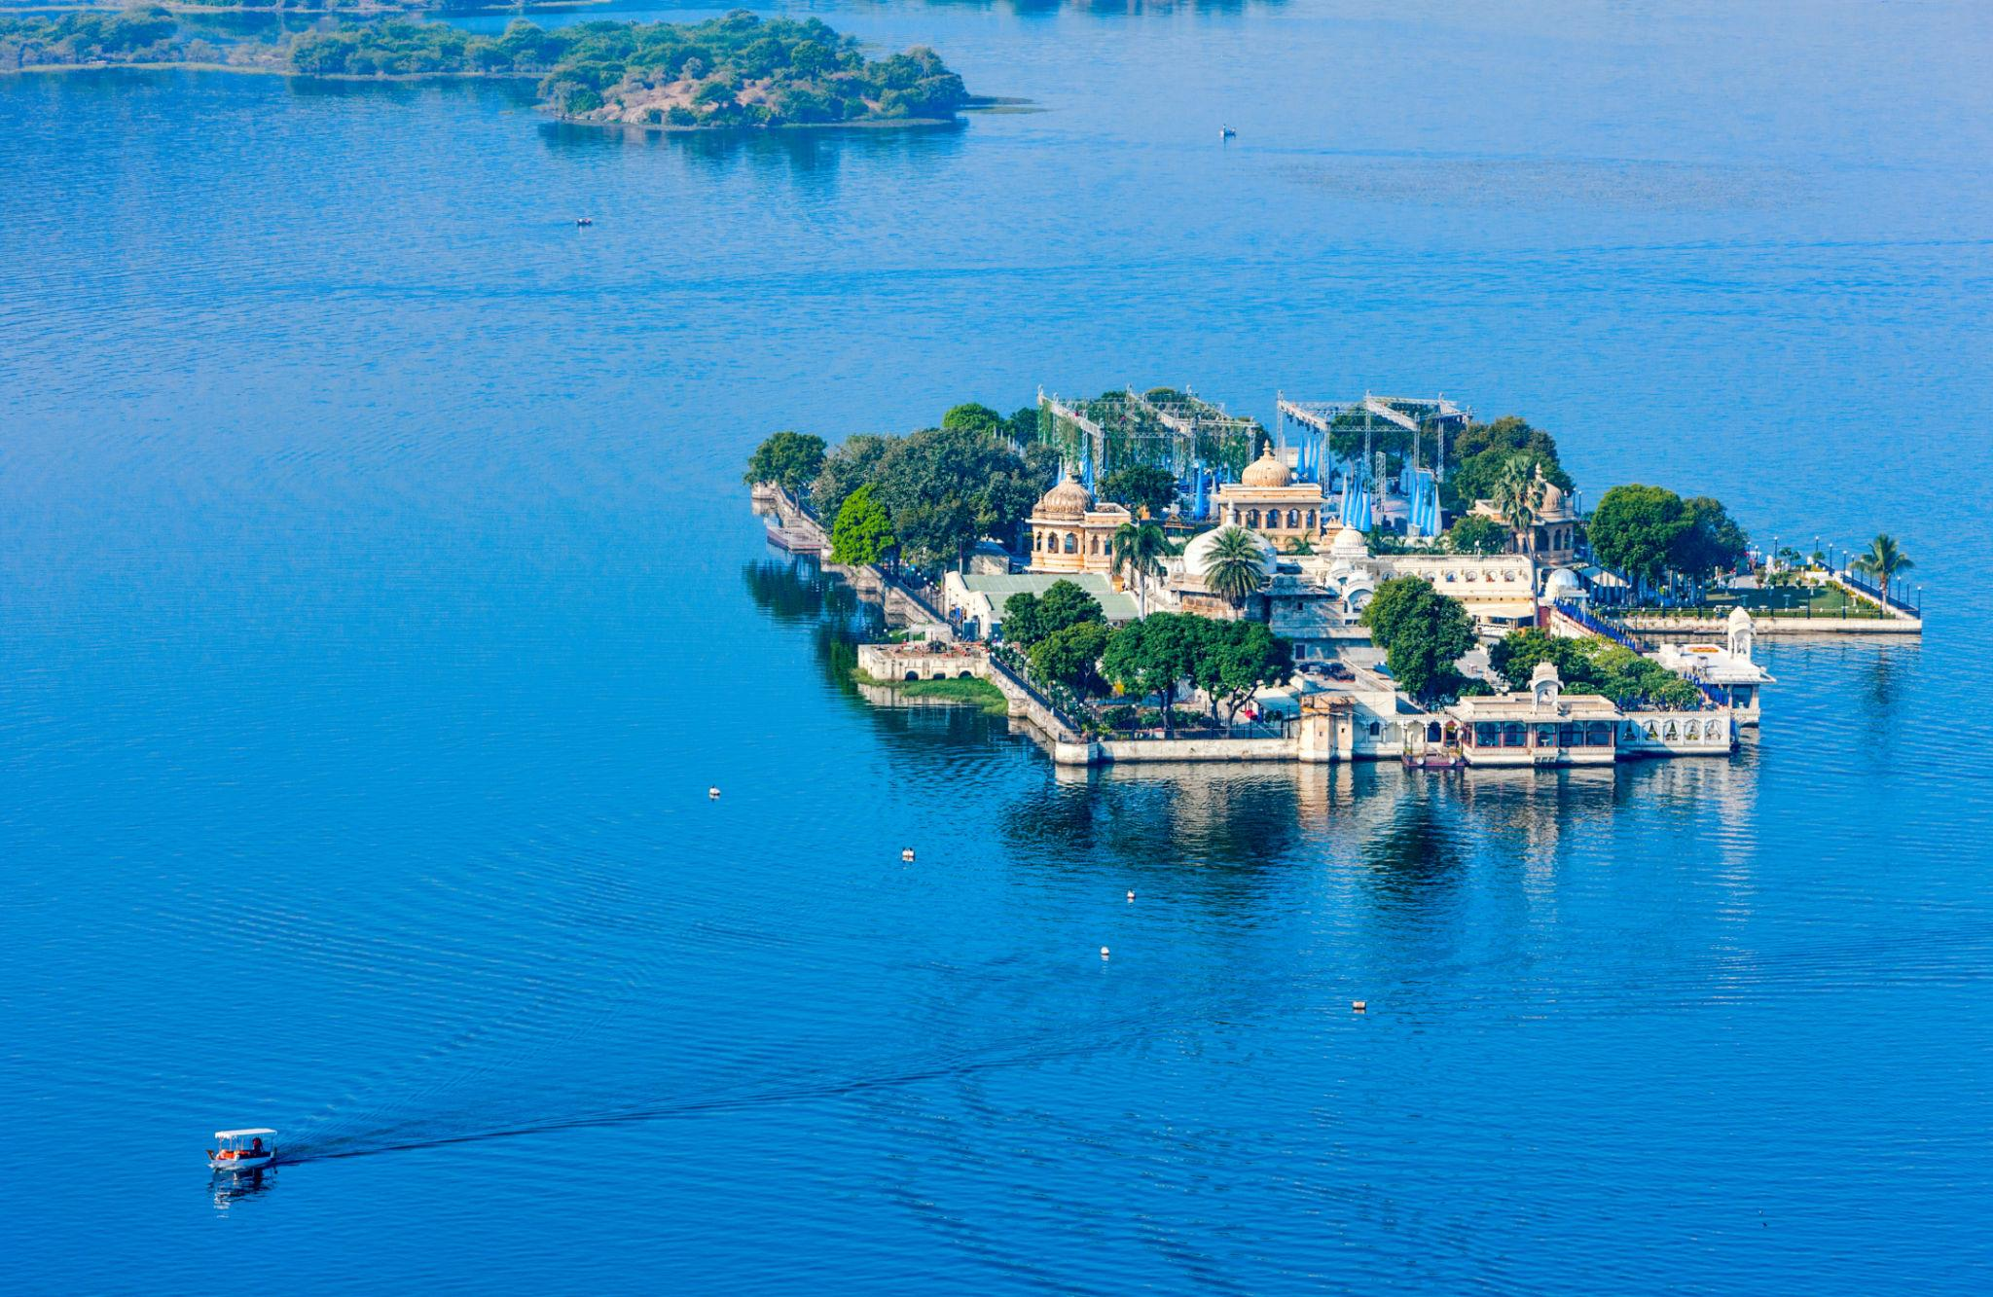
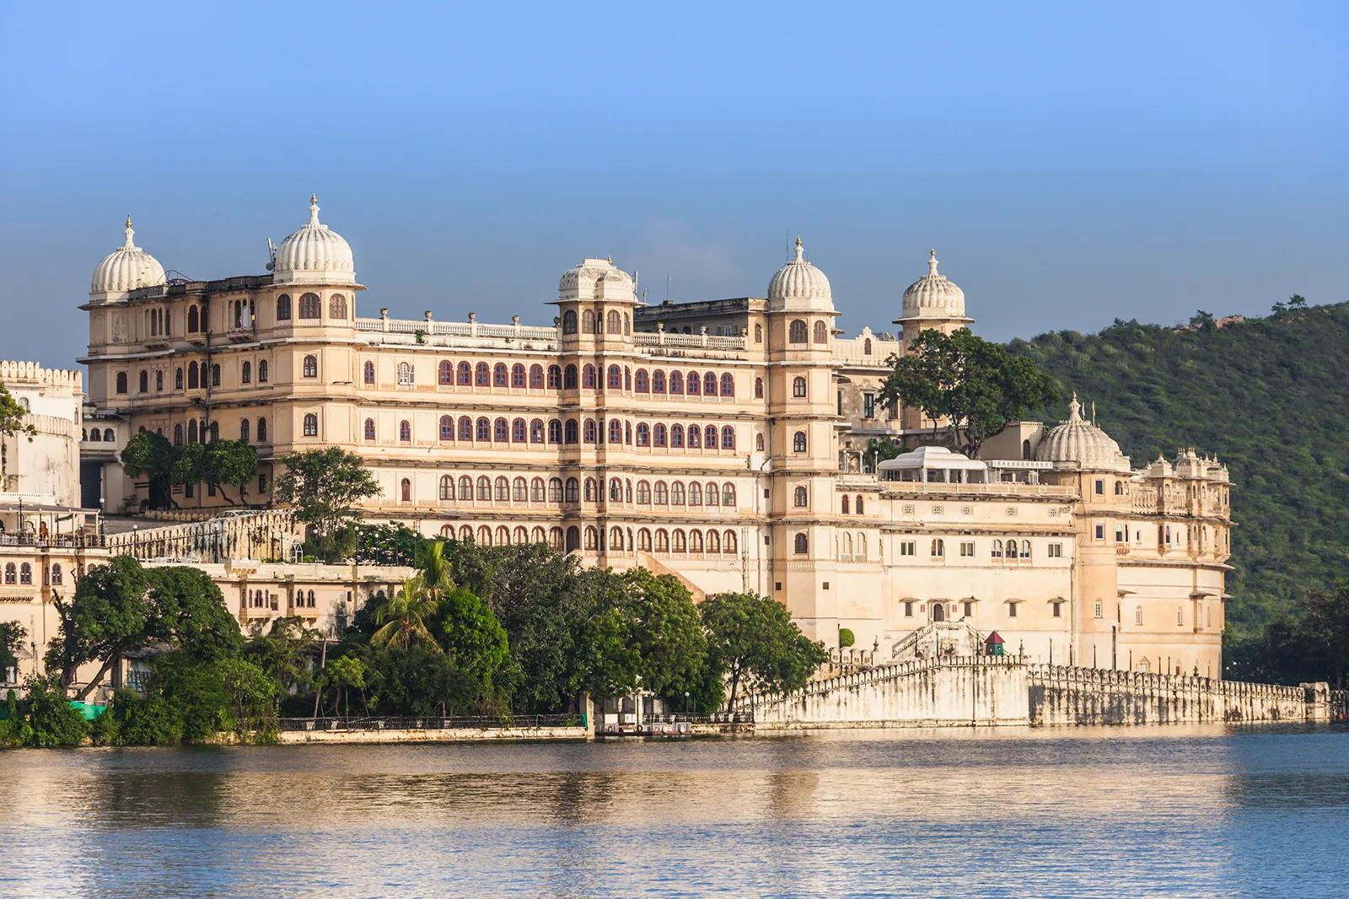
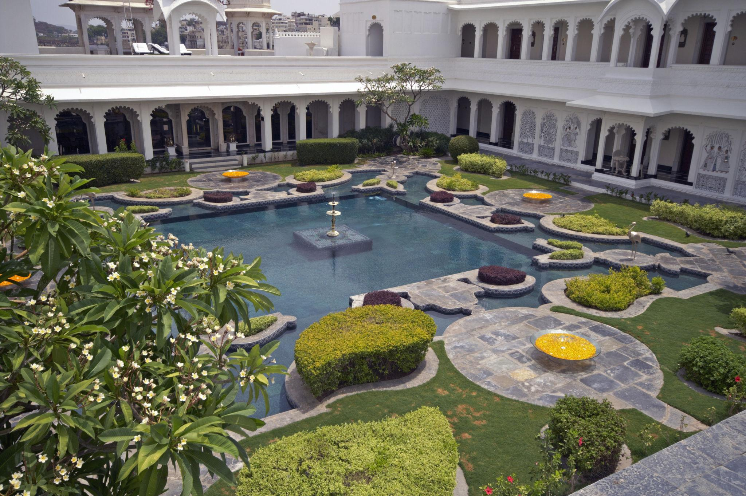

4. Sajjangarh Palace
Also known as the Monsoon Palace, offering panoramic views of Udaipur city and lakes.
Best for:
- Sunset views
- Scenic photography
- Hilltop landscapes
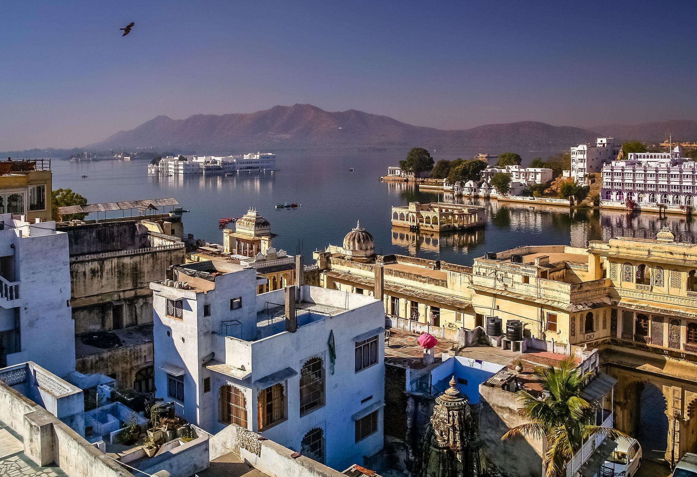
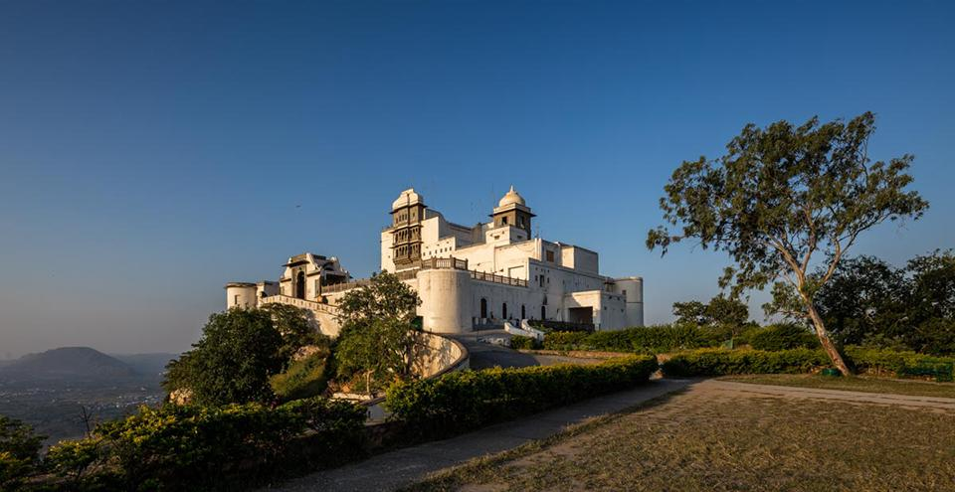
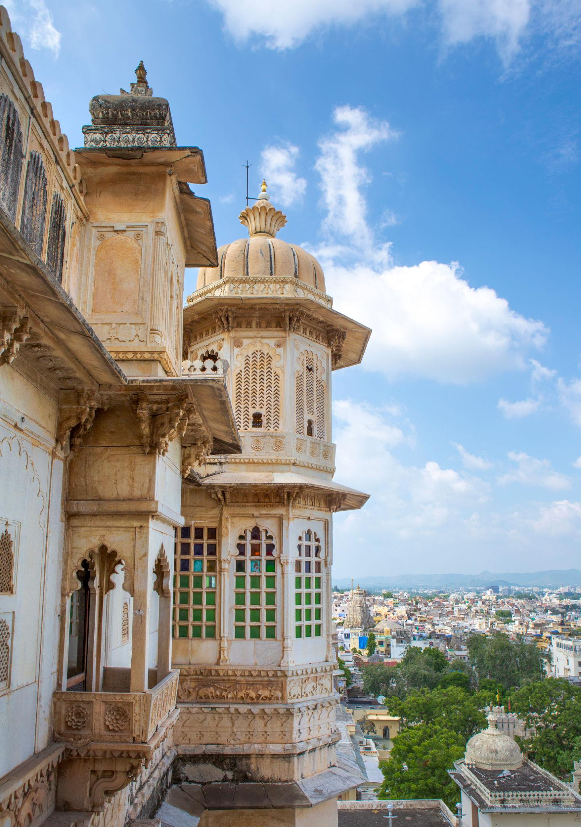
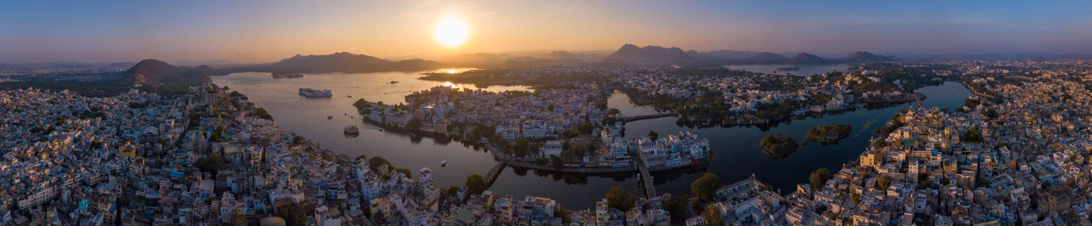
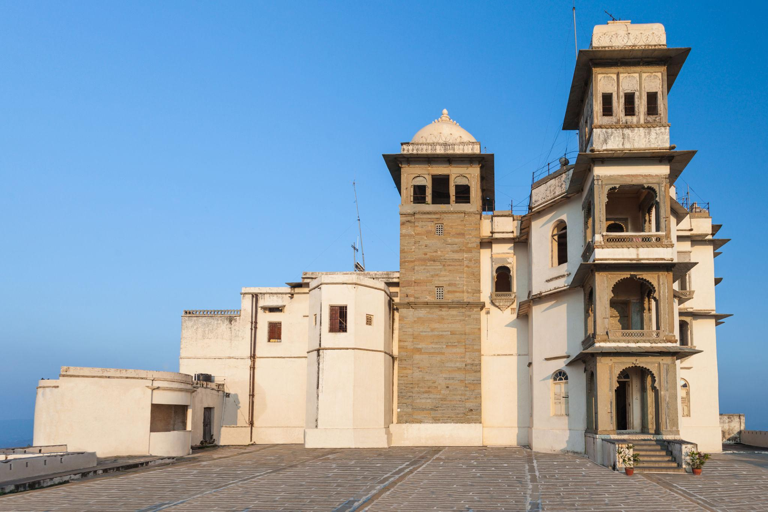
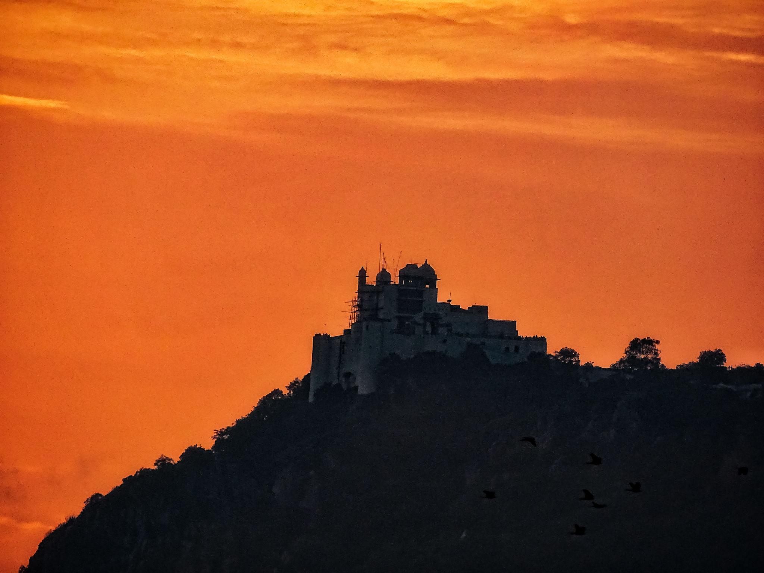
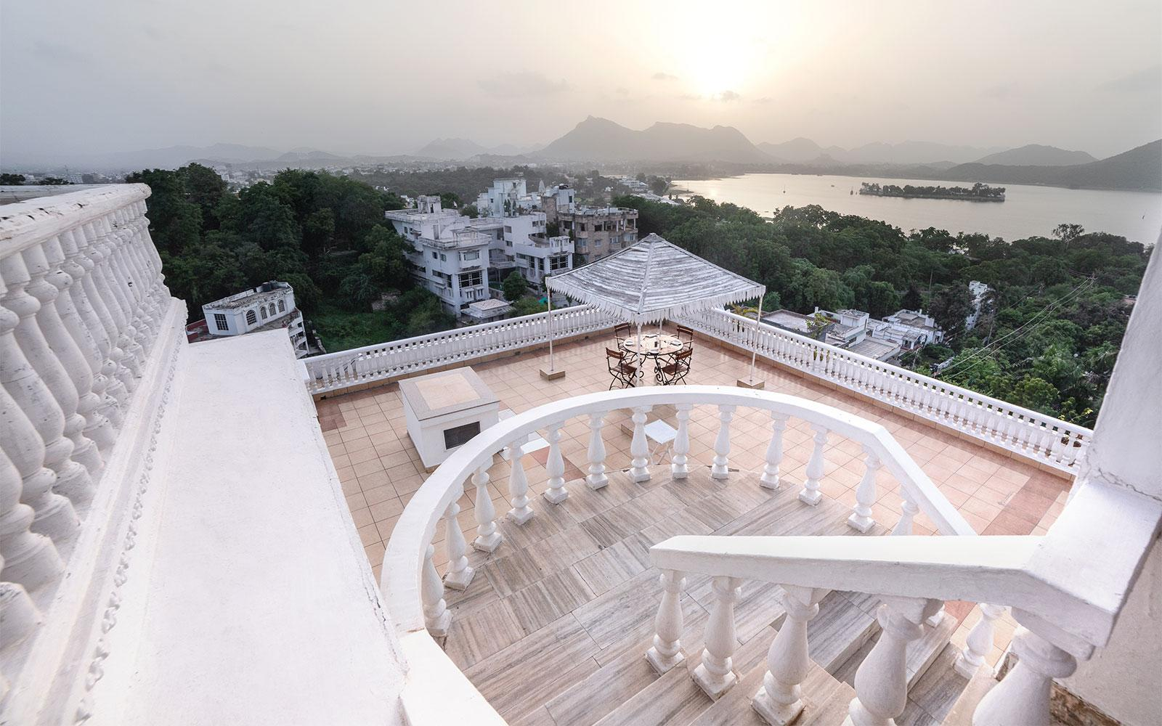
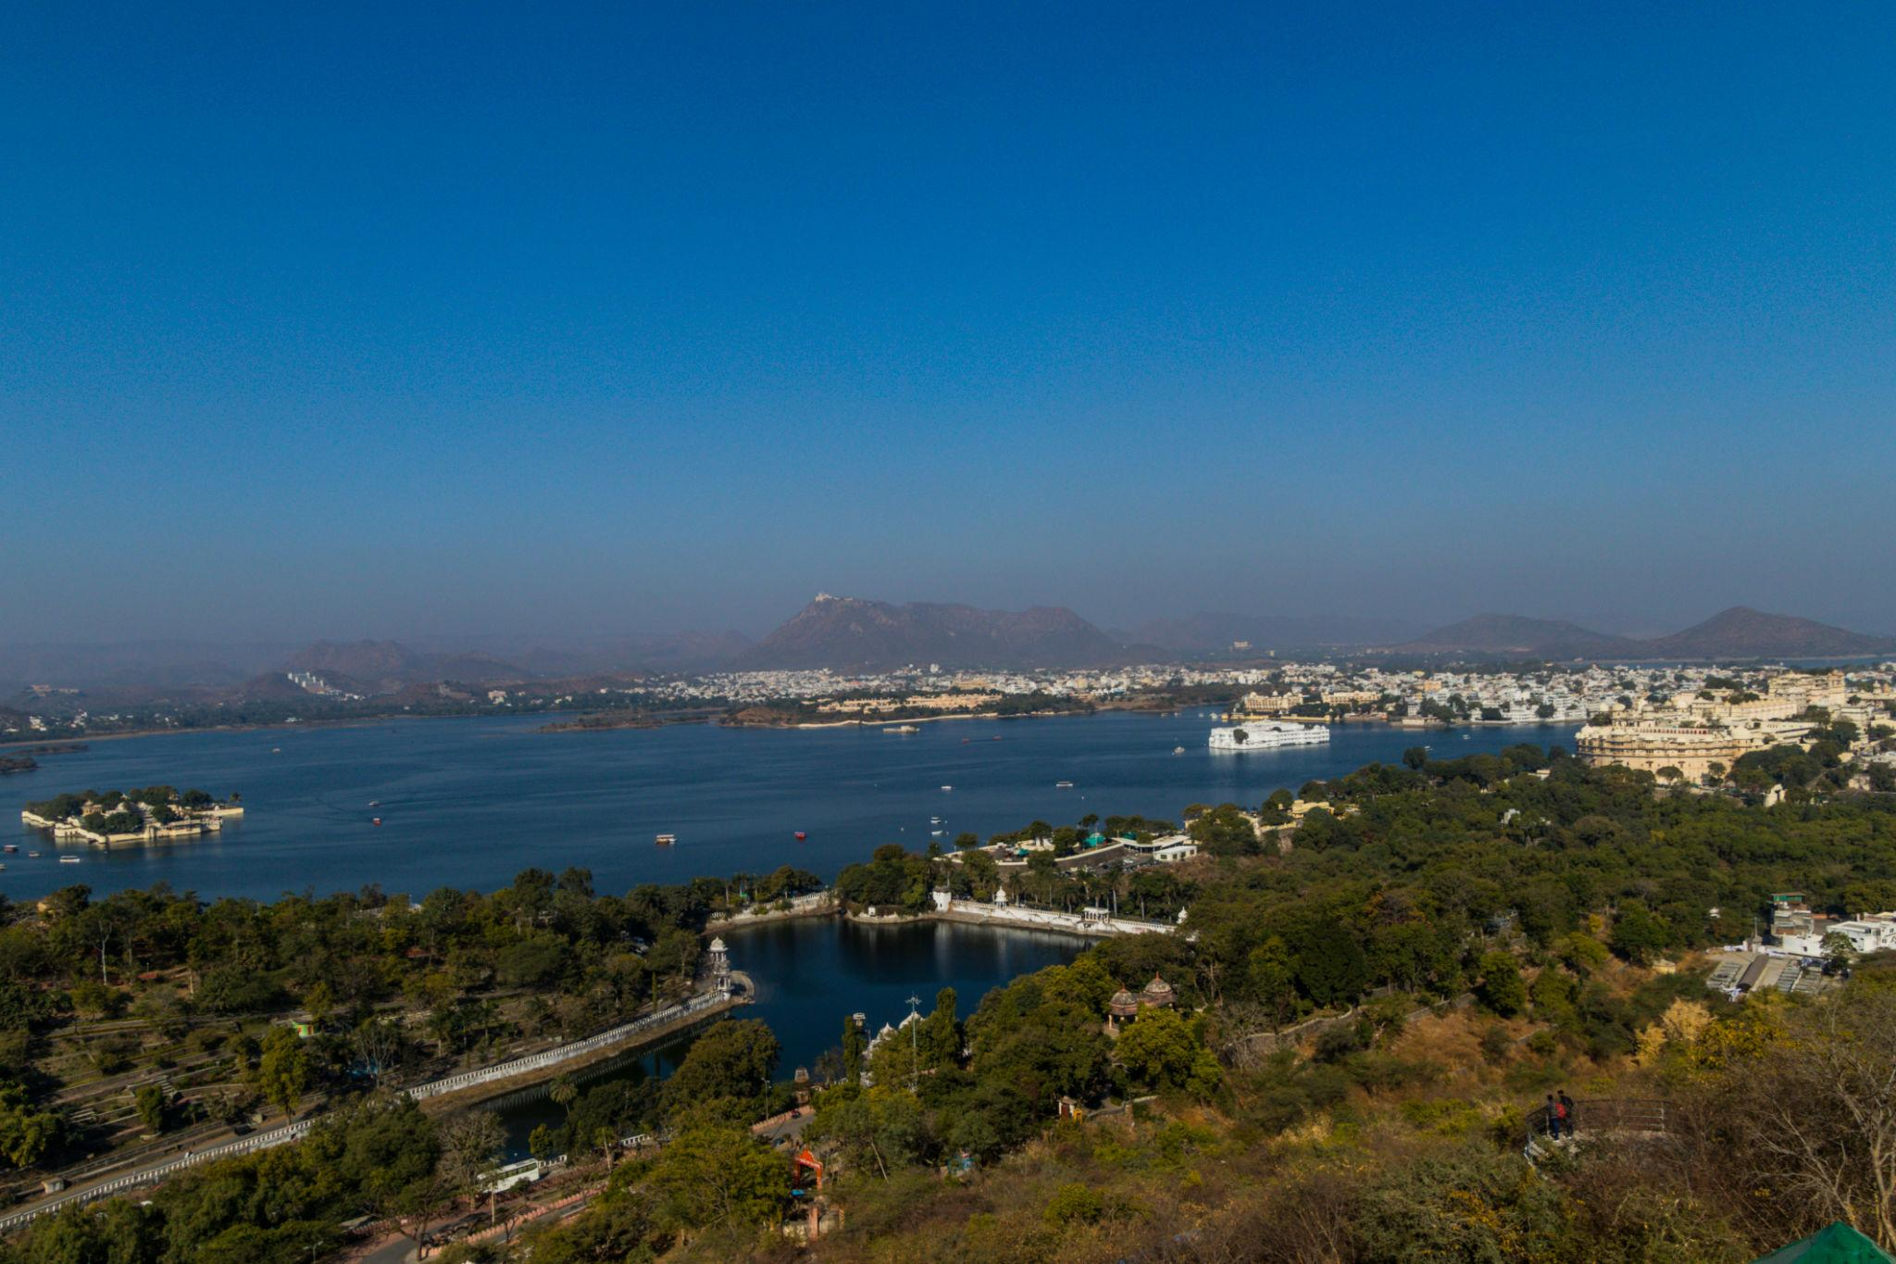

5. Fateh Sagar Lake
A beautiful artificial lake surrounded by hills and cafés.
Popular activities:
- Boating
- Evening walks
- Lakefront cafés
- Sunset sightseeing
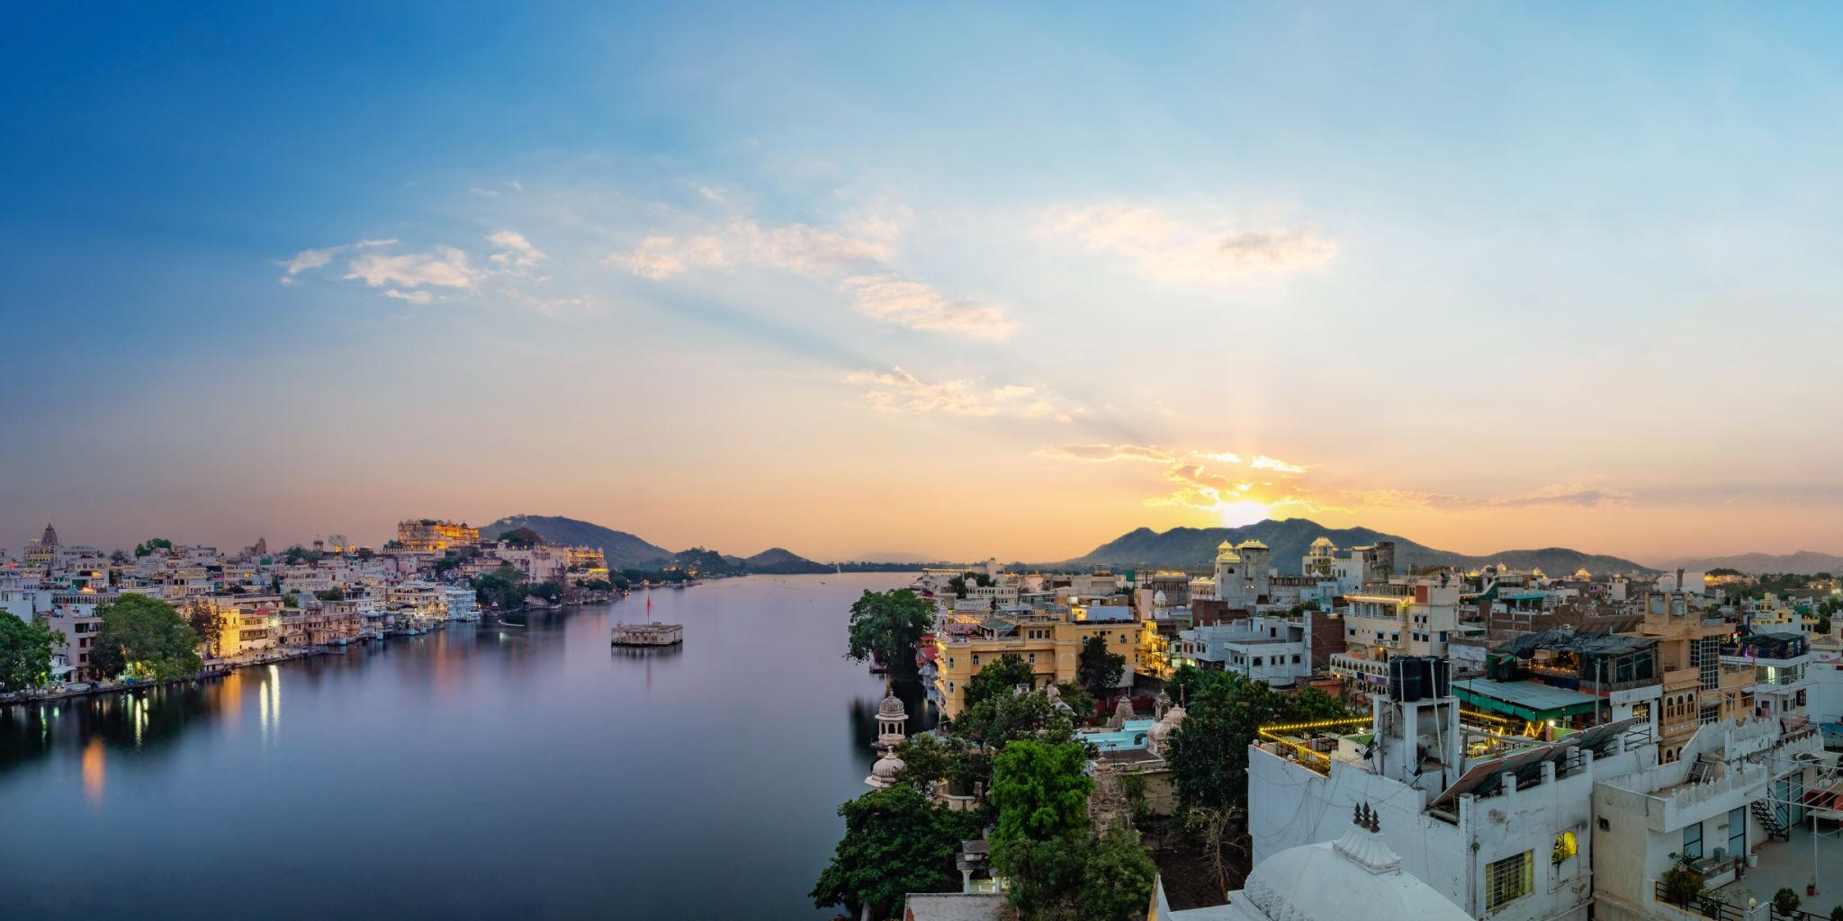
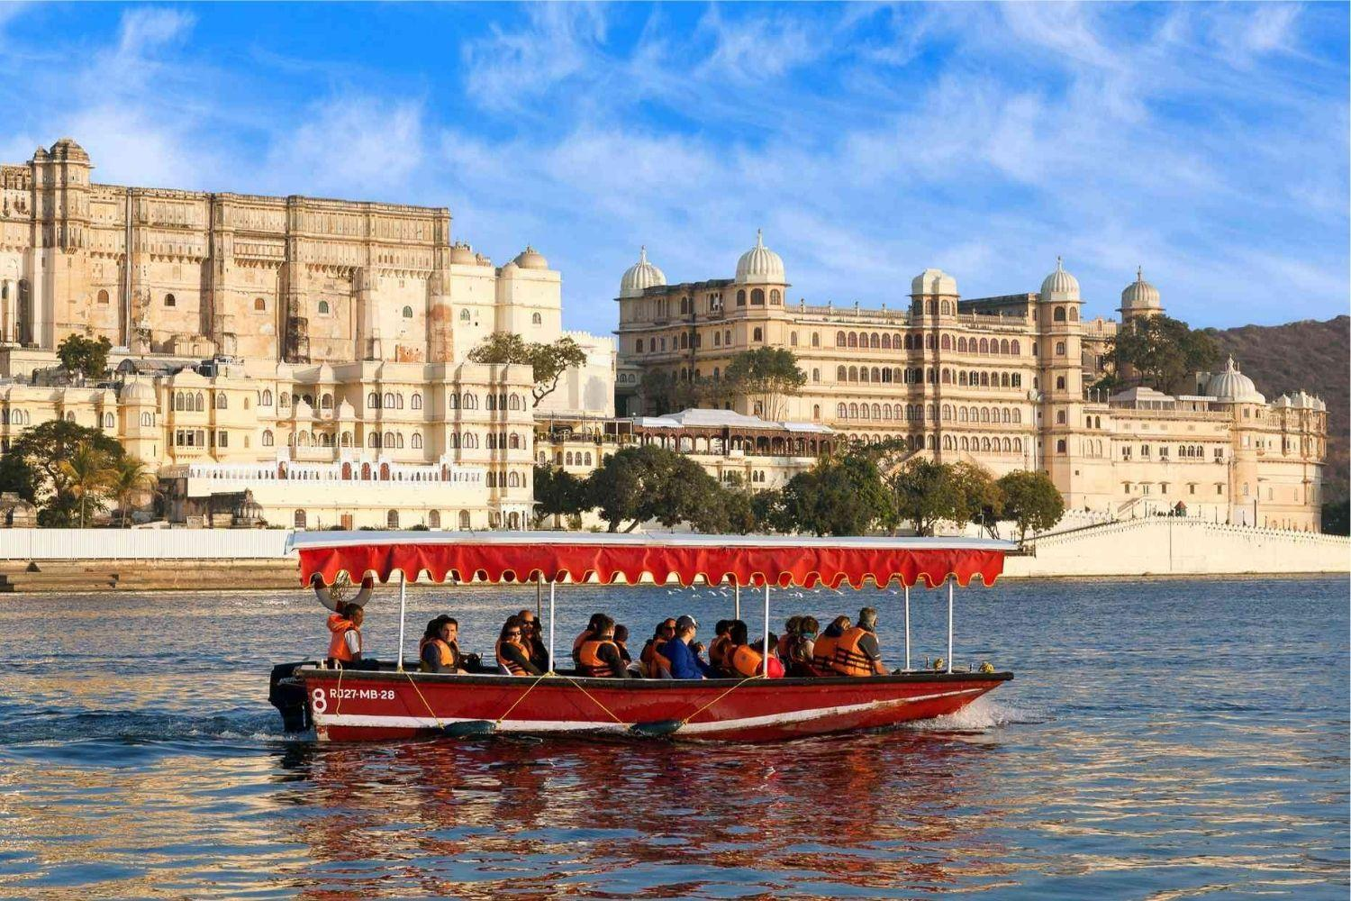
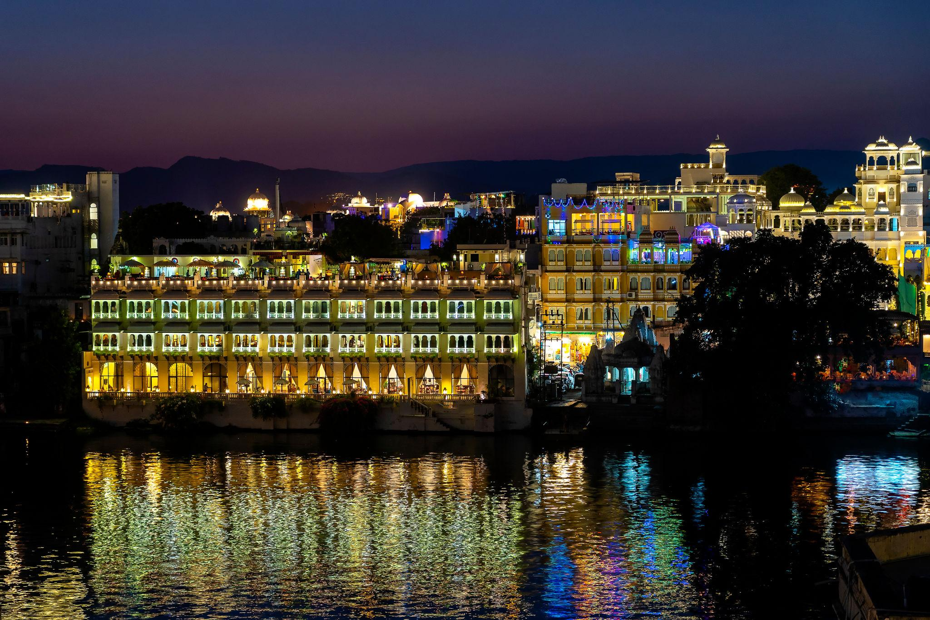
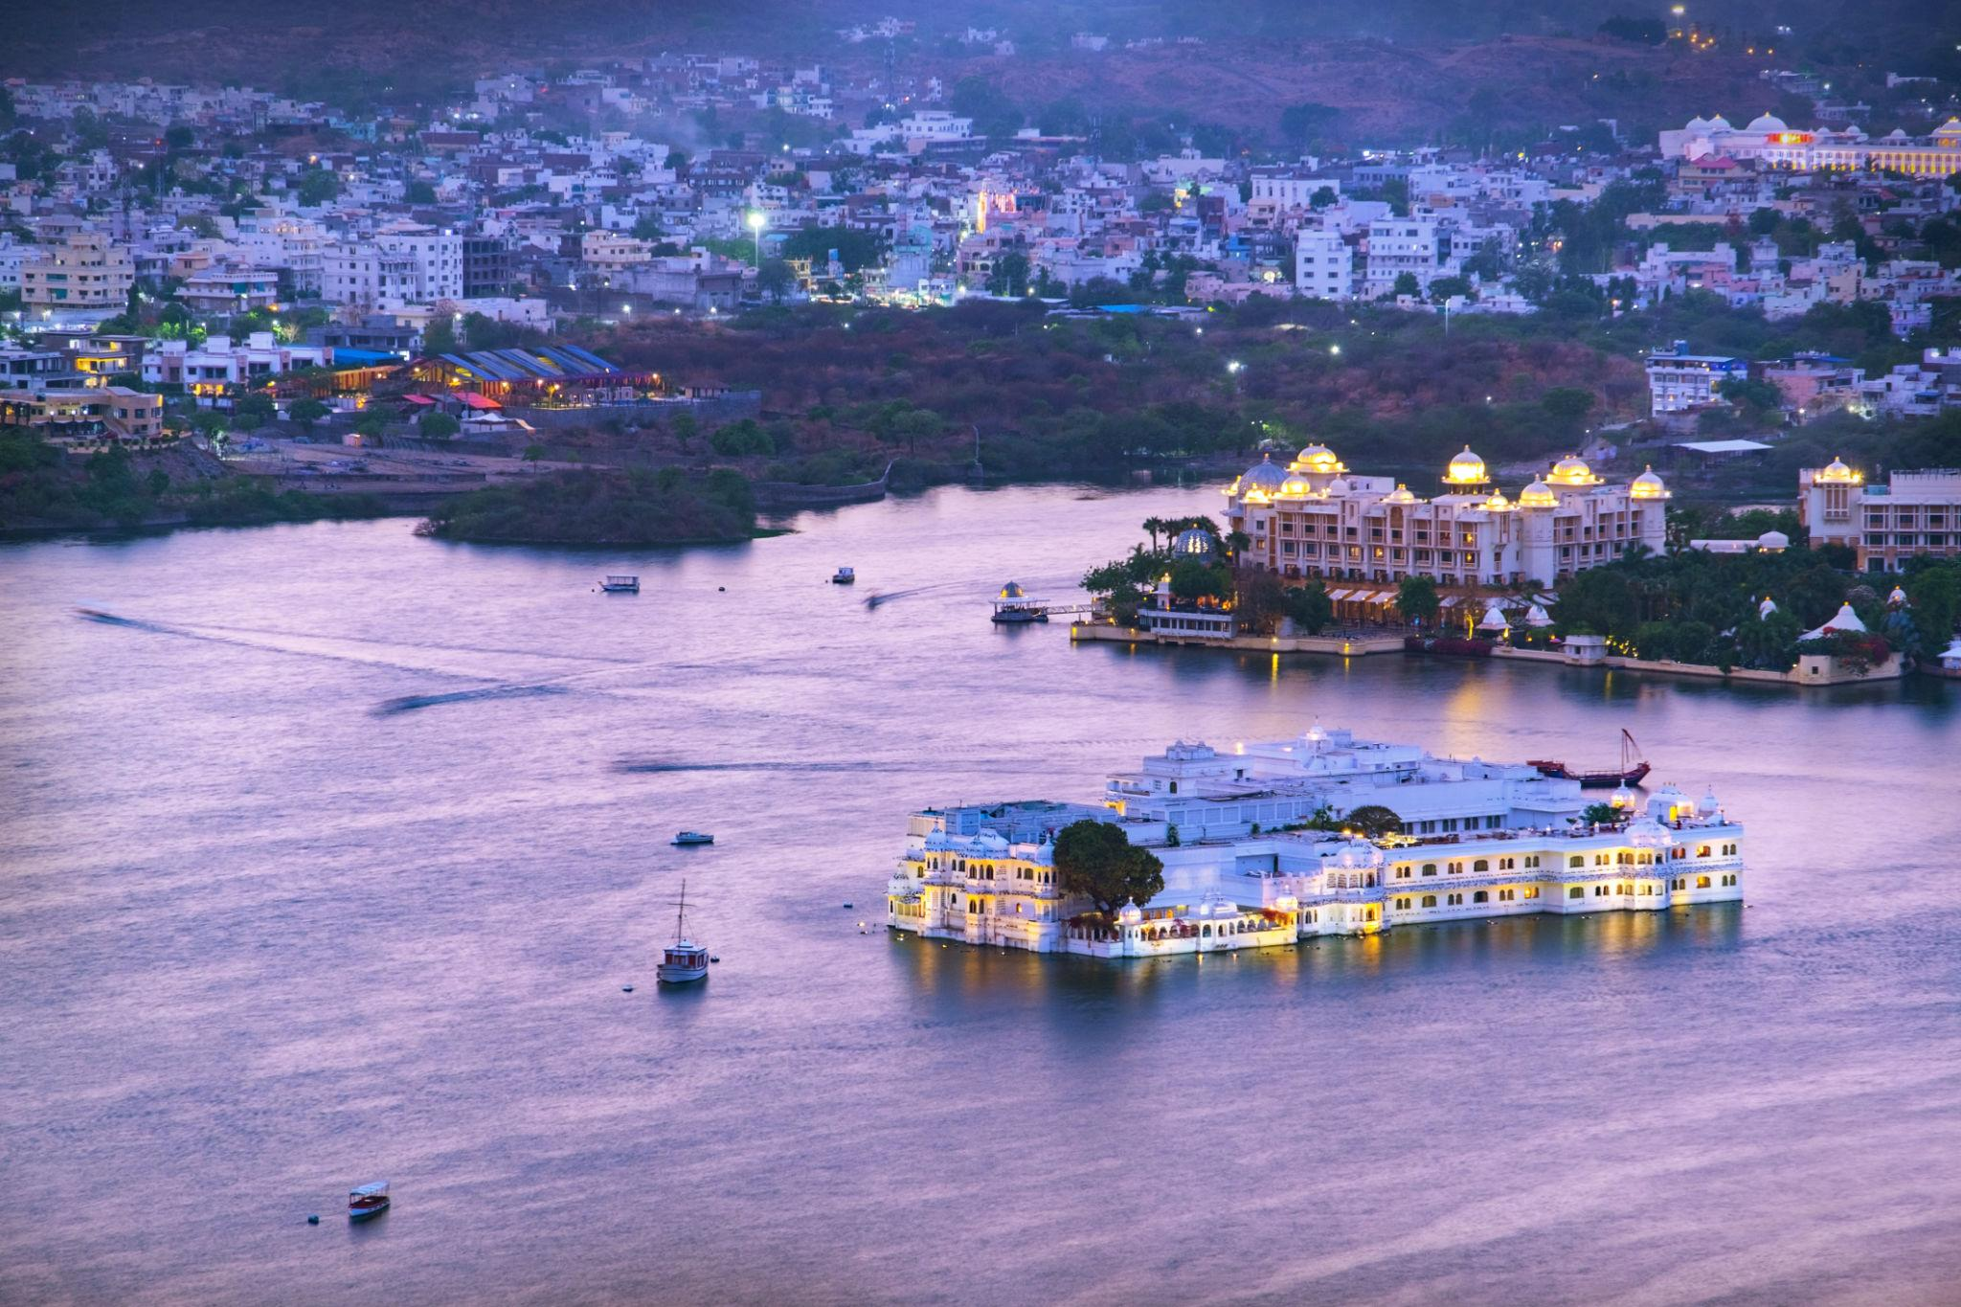
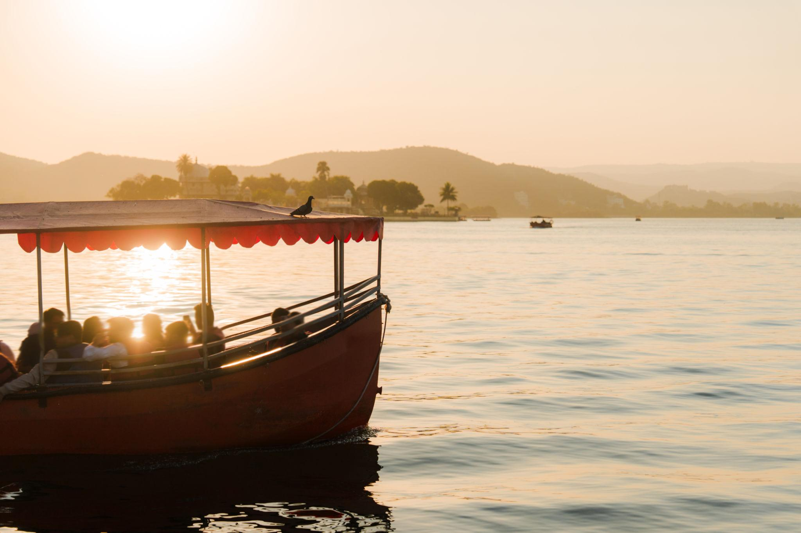
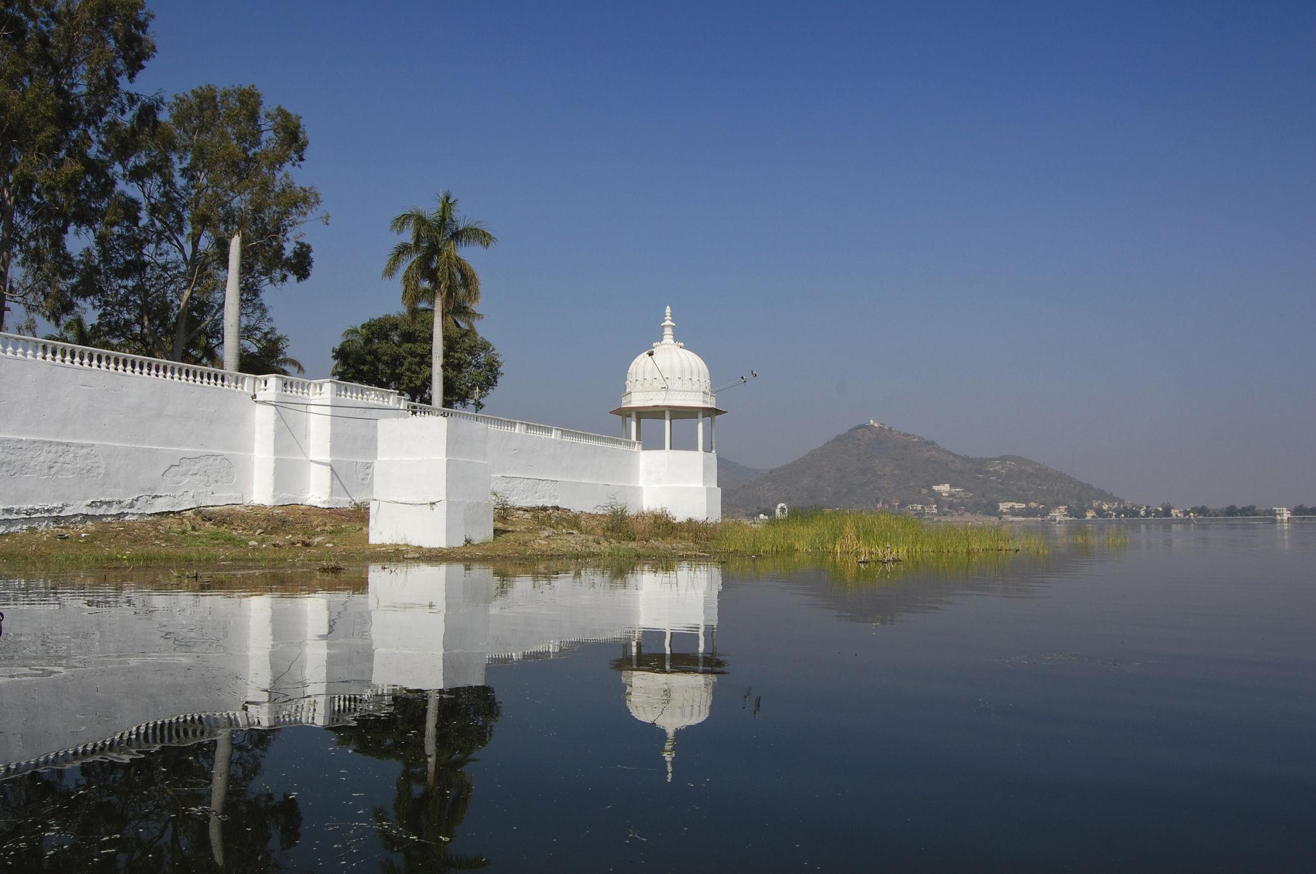
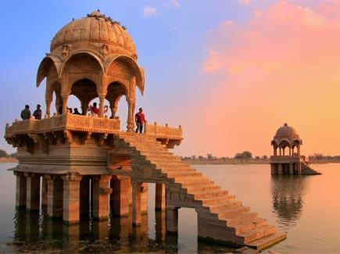

6. Bagore Ki Haveli
A historic haveli famous for cultural performances and royal architecture.
Highlights:
- Traditional dance shows
- Puppet performances
- Heritage interiors
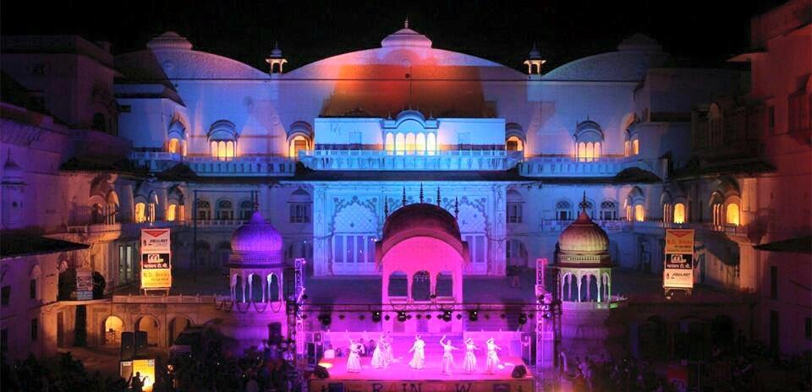
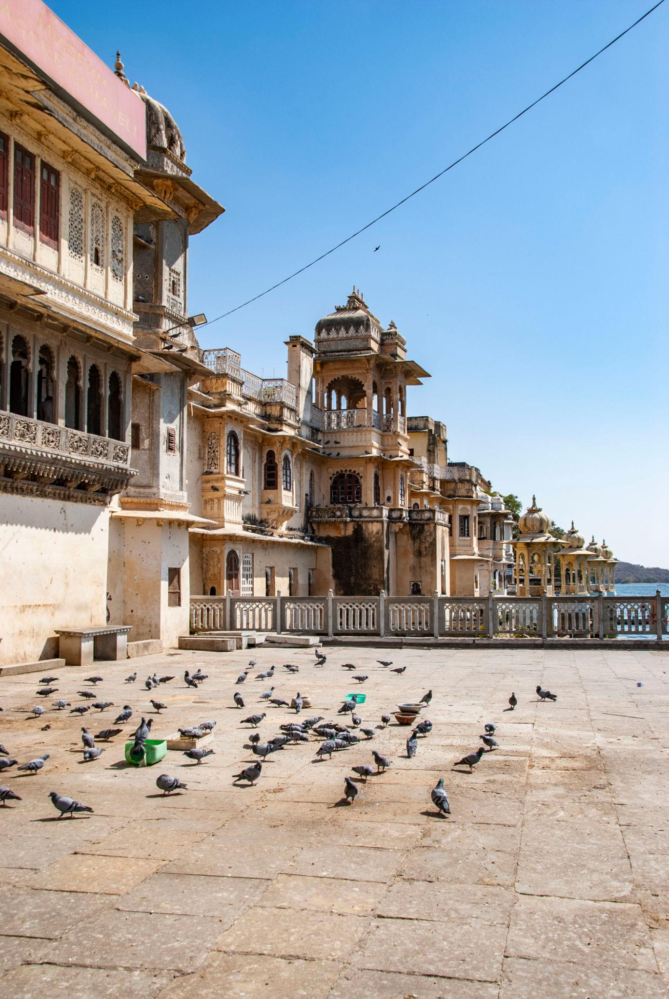
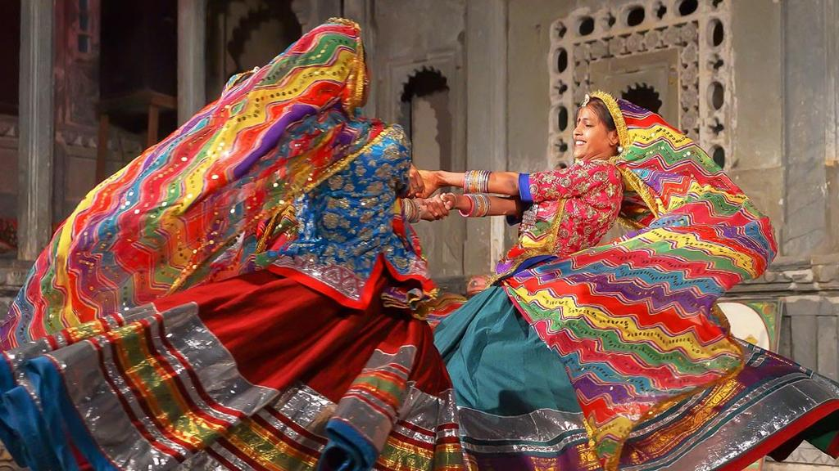
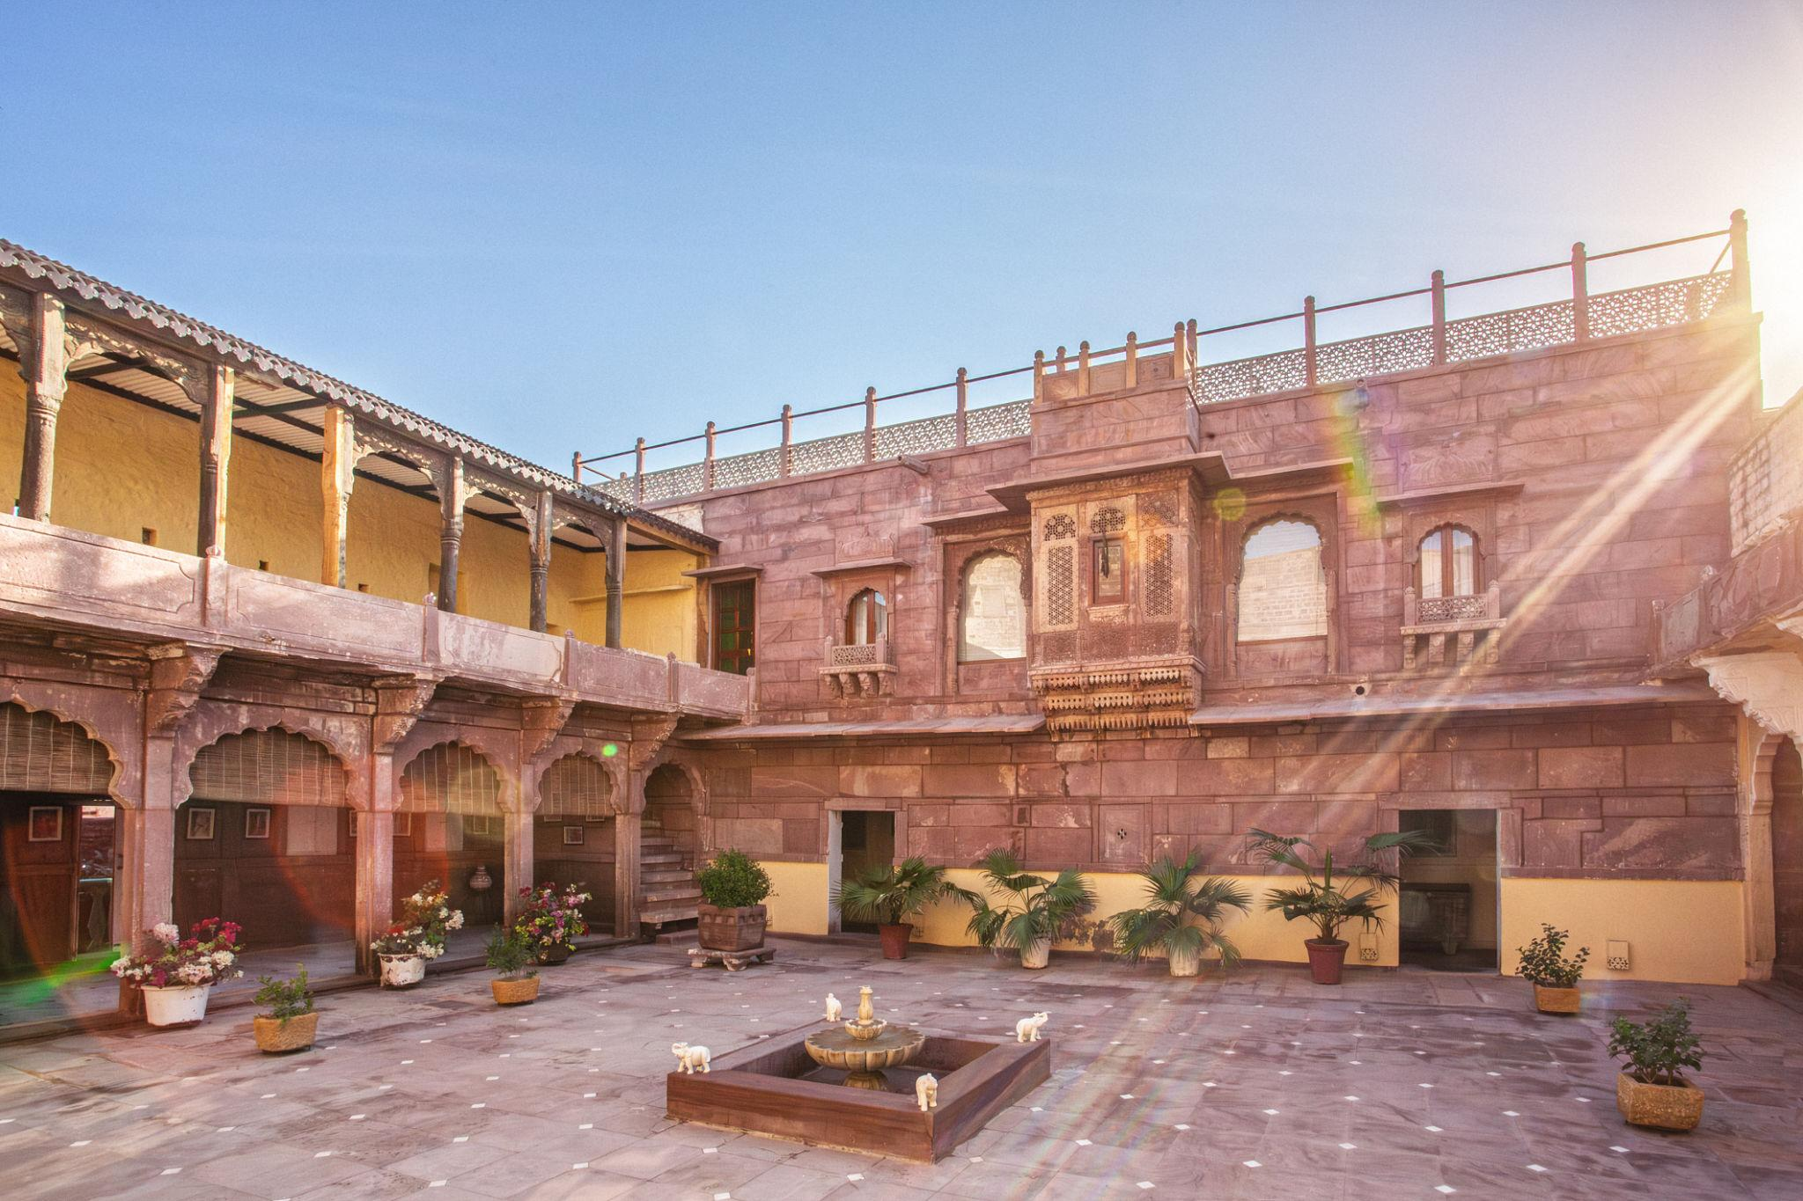
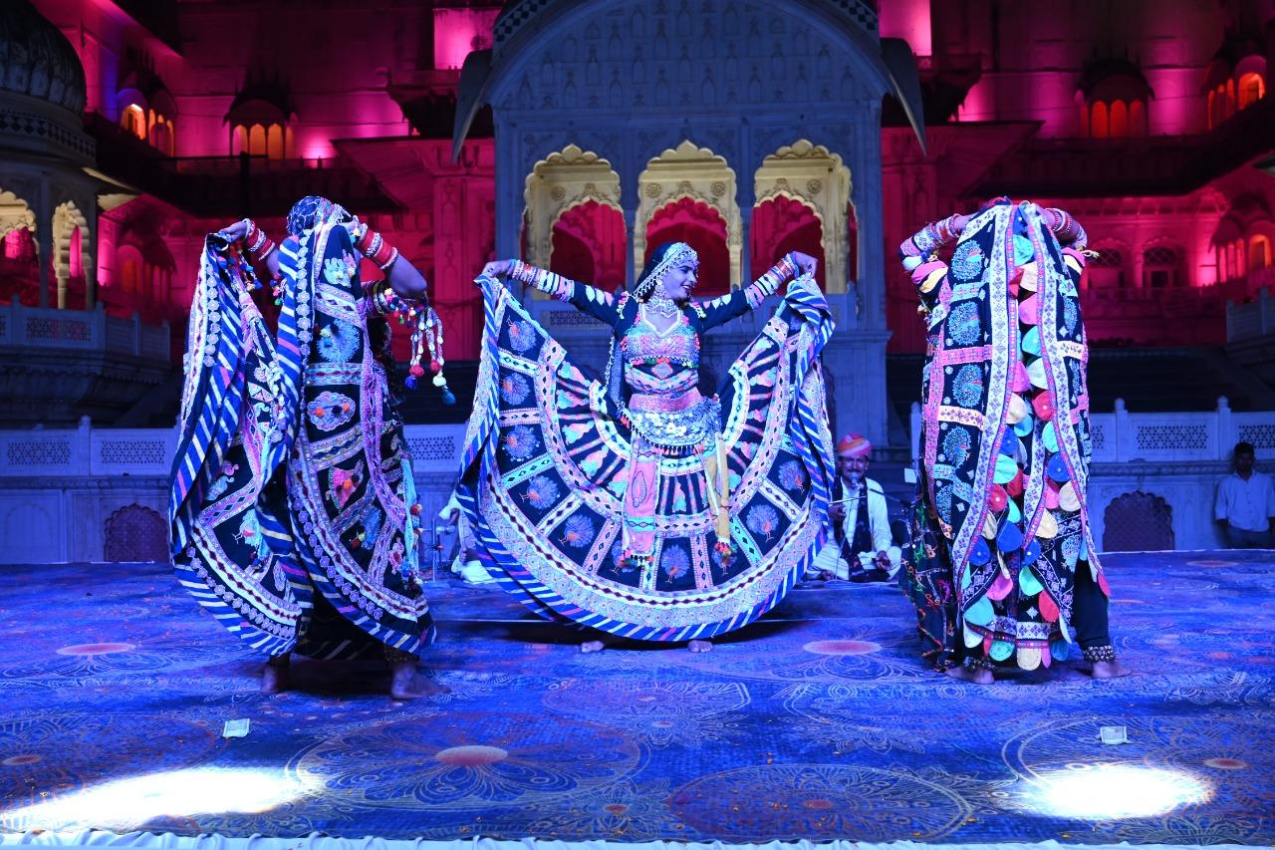
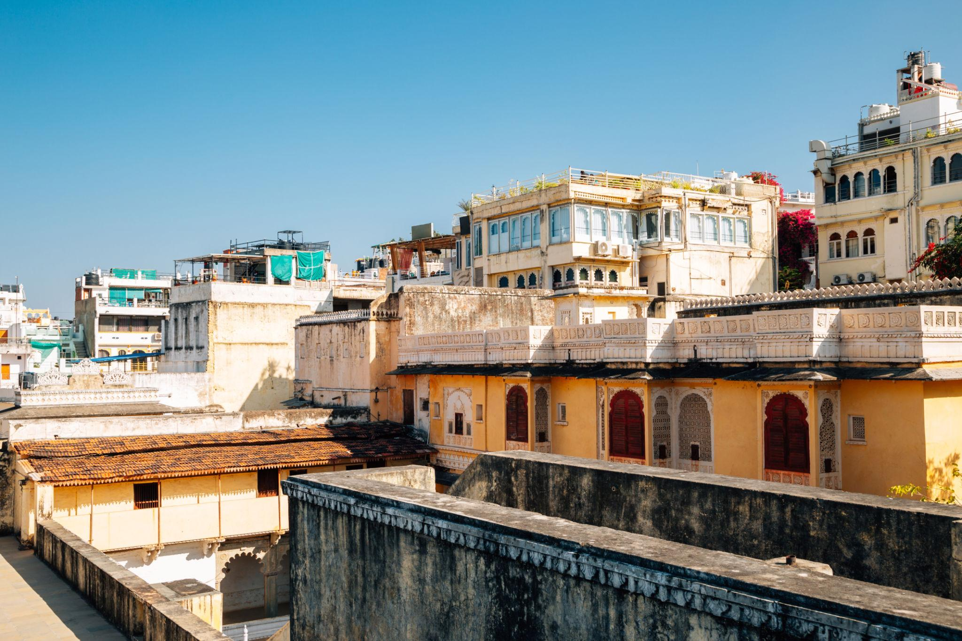

Best Things to Do in Udaipur
- Enjoy boat rides on Lake Pichola
- Explore royal palaces & havelis
- Watch cultural dance performances
- Experience luxury heritage stays
- Shop in traditional bazaars
- Enjoy rooftop dining with lake views
- Visit temples & gardens
- Capture sunset photography

Famous Markets & Shopping in Udaipur 🛍️
Popular Shopping Places:
- Hathi Pol Bazaar
- Bada Bazaar
- Shilpgram
- Clock Tower Market
Famous items:
- Miniature paintings
- Rajasthani handicrafts
- Silver jewelry
- Traditional textiles
- Leather products
- Handmade souvenirs
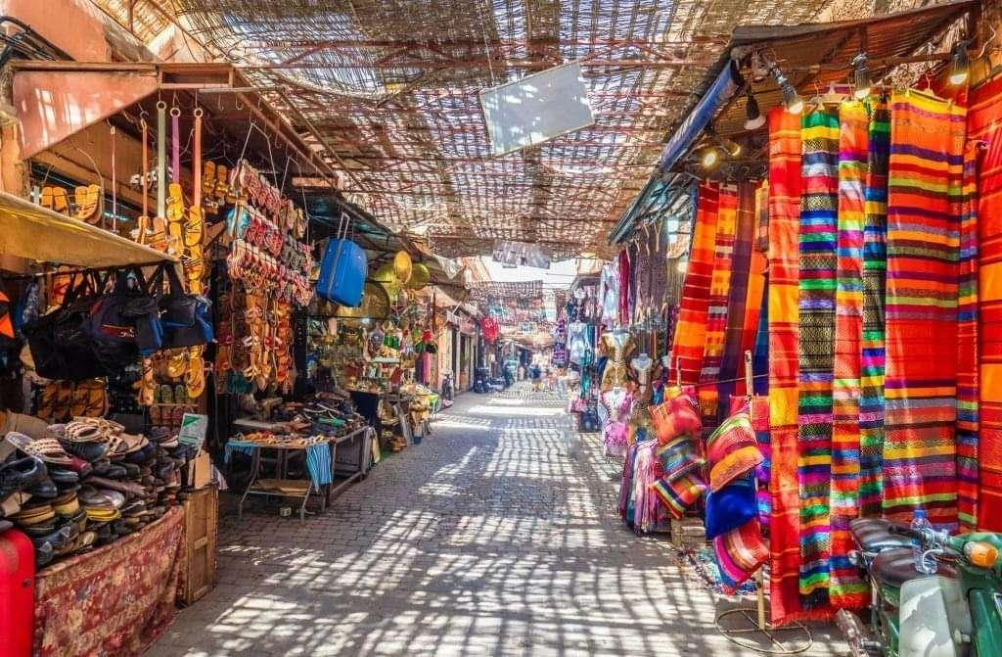
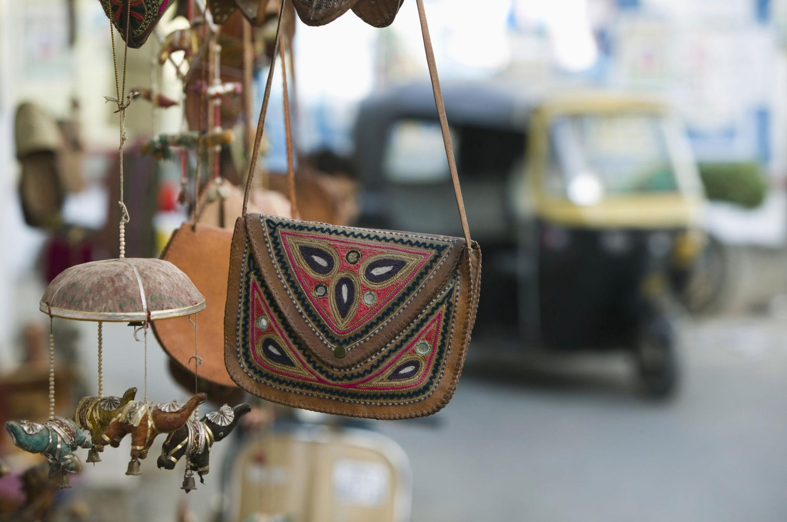
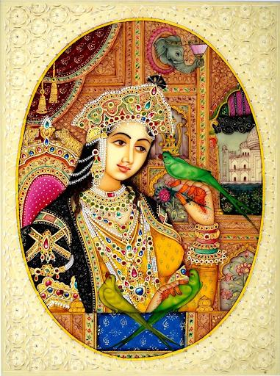
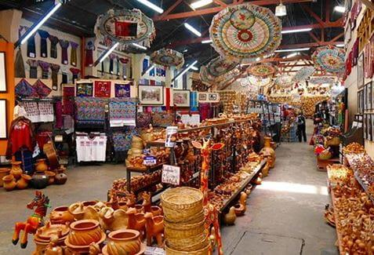
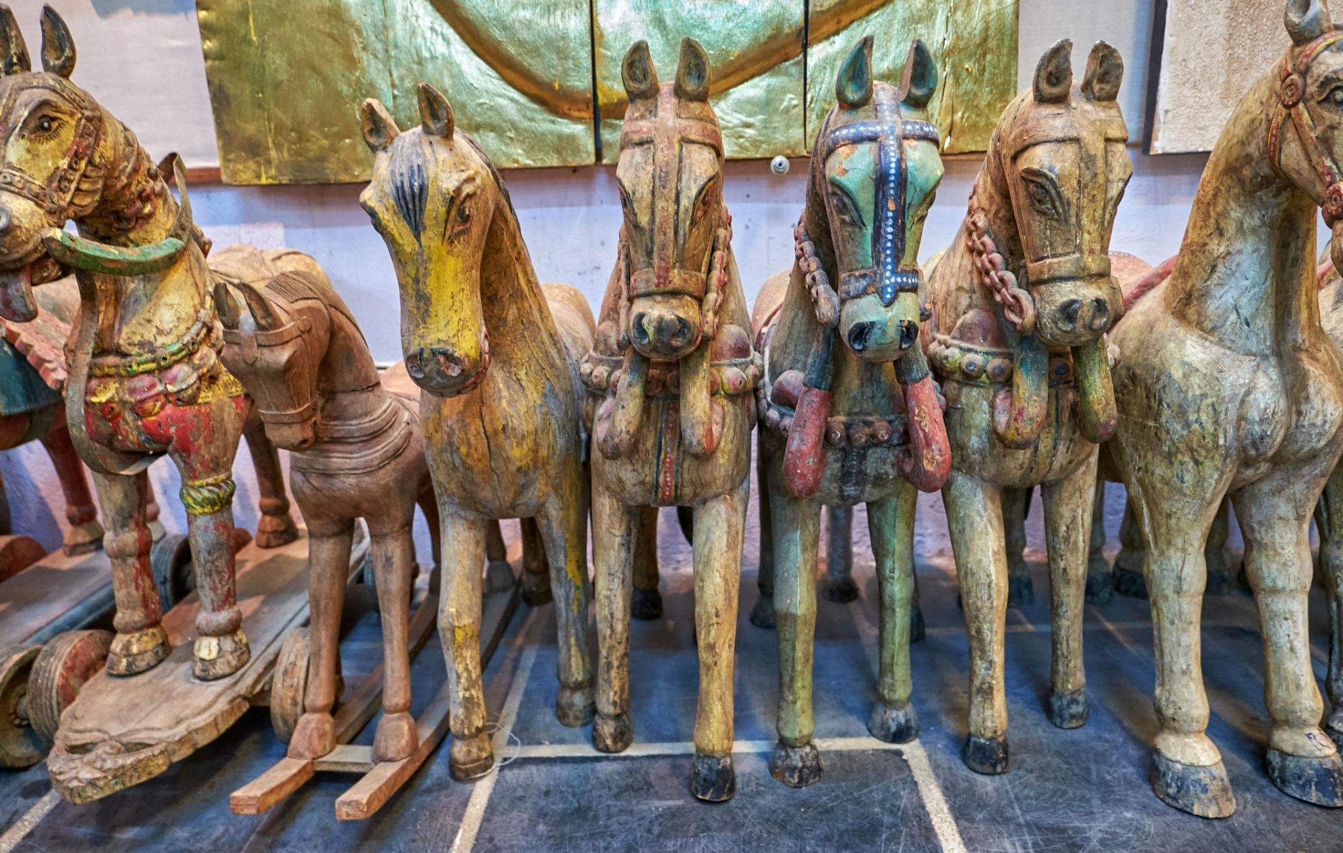
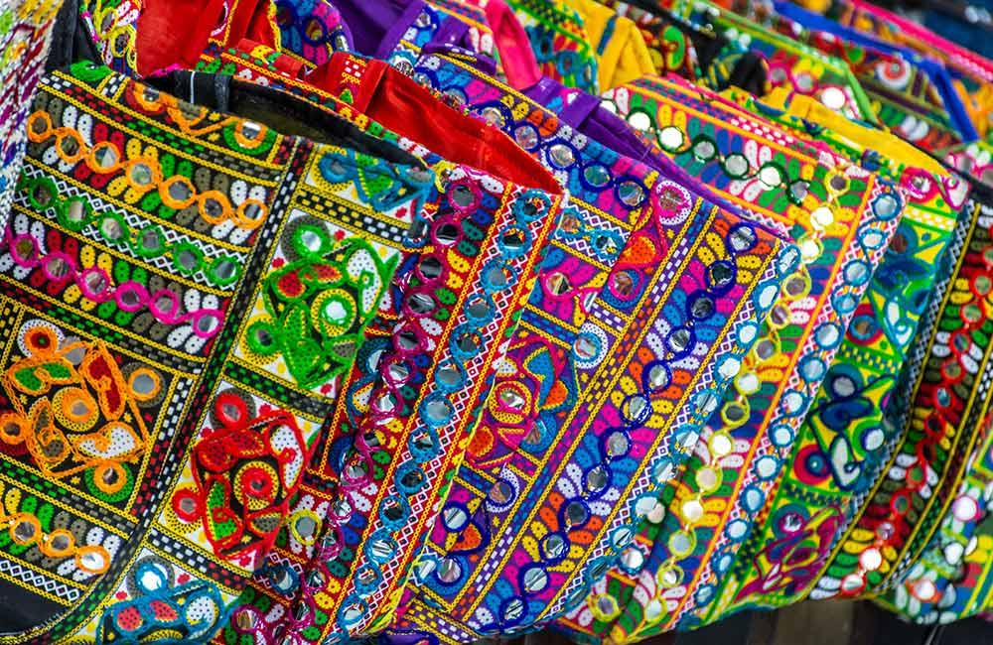
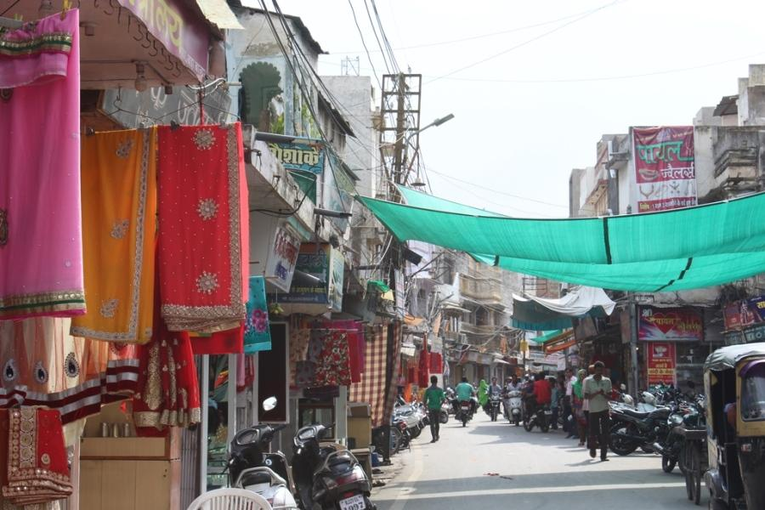
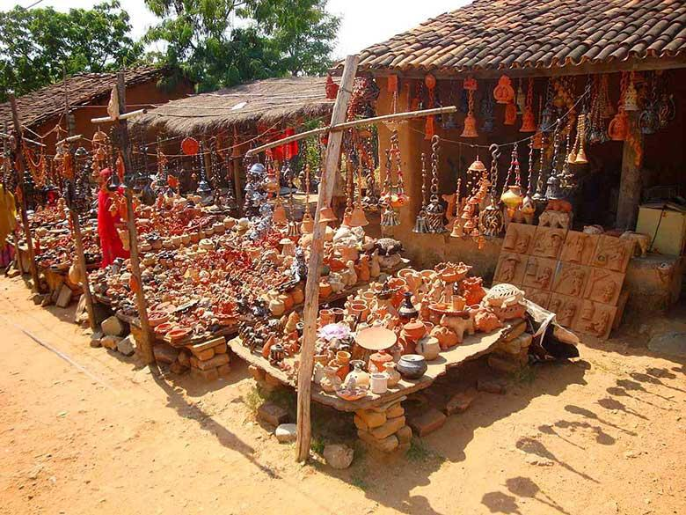

Best Time to Visit Udaipur
Season | Months | Weather
Winter | October – March | Pleasant & best for sightseeing
Summer | April – June | Warm but manageable
Monsoon | July – September | Beautiful greenery & romantic weather
Winter is considered the best season to visit Udaipur.

How to Reach Udaipur
By Air
Main airport:
- Maharana Pratap Airport
By Train
Udaipur is connected to major cities including:
- Delhi
- Jaipur
- Mumbai
- Ahmedabad
By Road
Excellent highway connectivity from:
- Jaipur
- Jodhpur
- Mount Abu
- Ahmedabad

Famous Foods to Try in Udaipur 🍴
- Dal Baati Churma
- Gatte Ki Sabzi
- Laal Maas
- Kachori
- Ghewar
- Rajasthani Thali
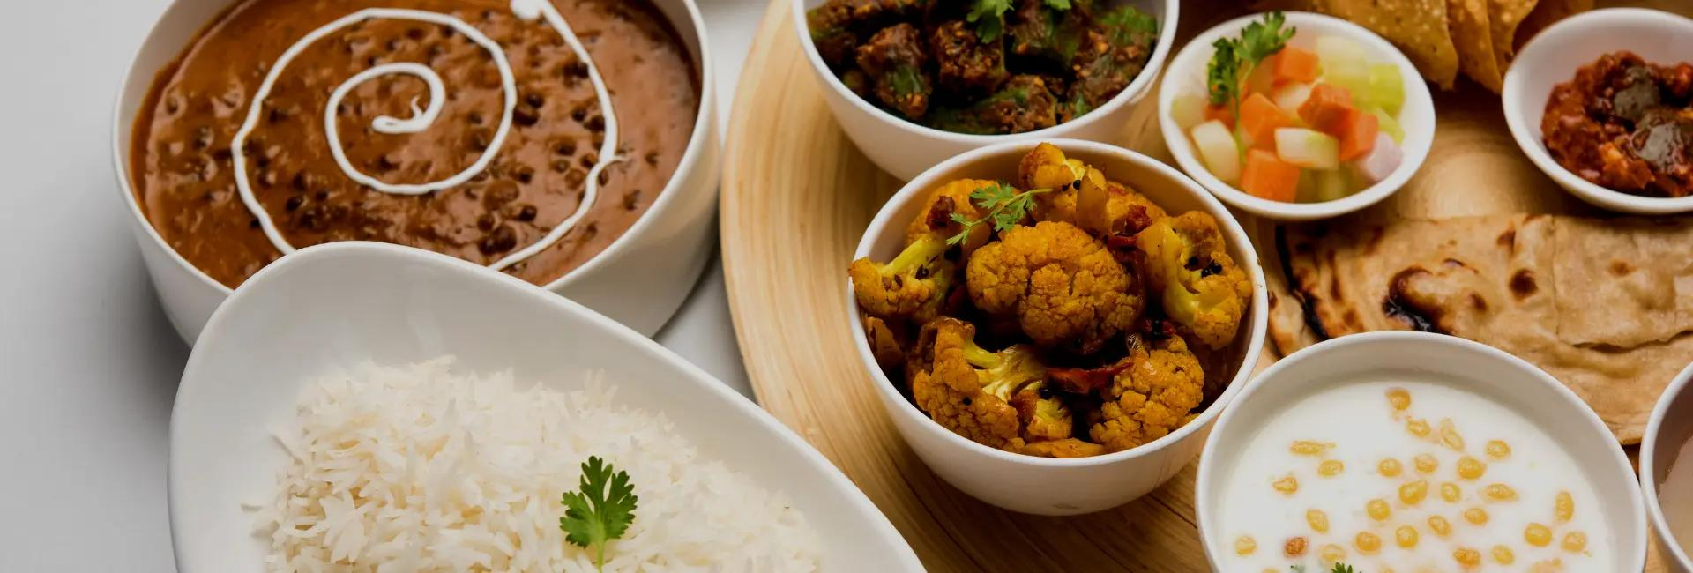
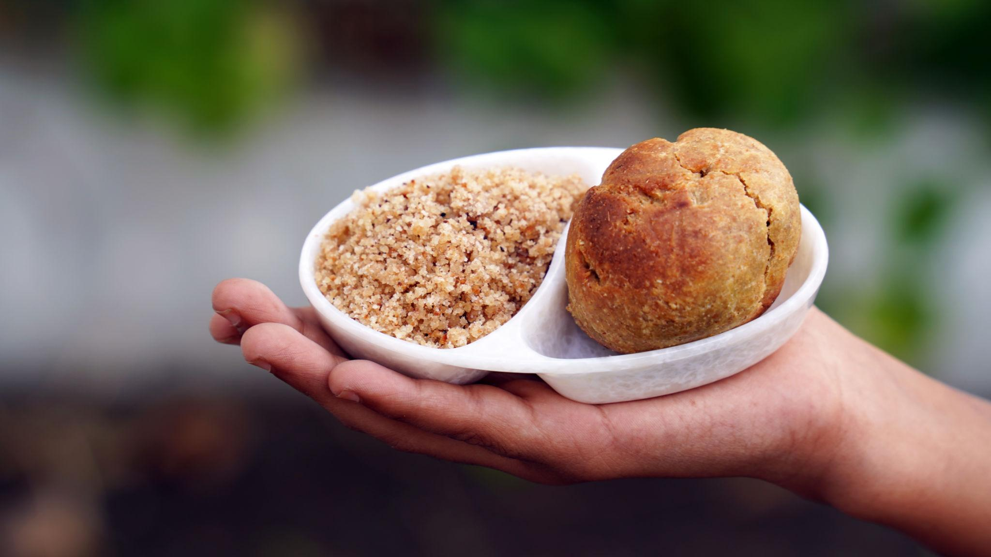
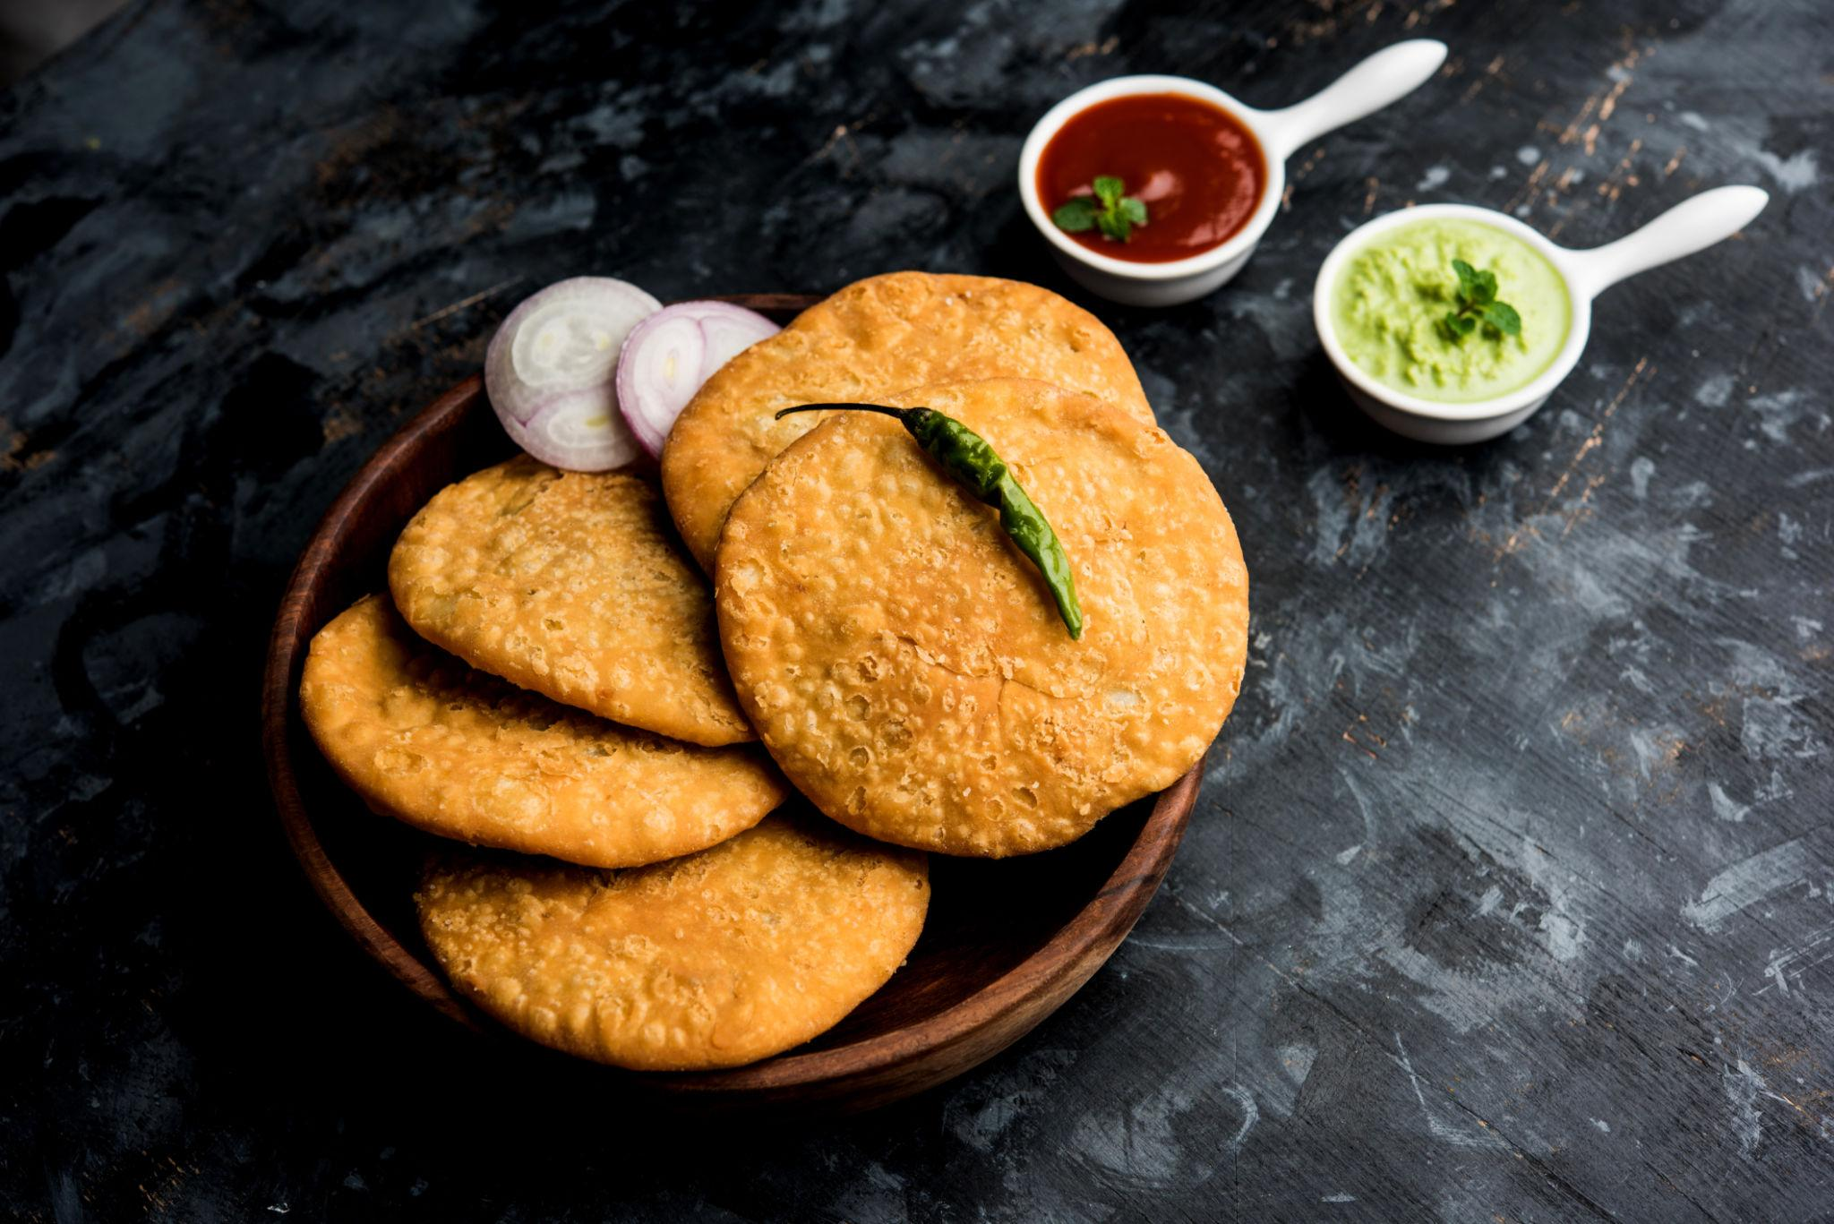
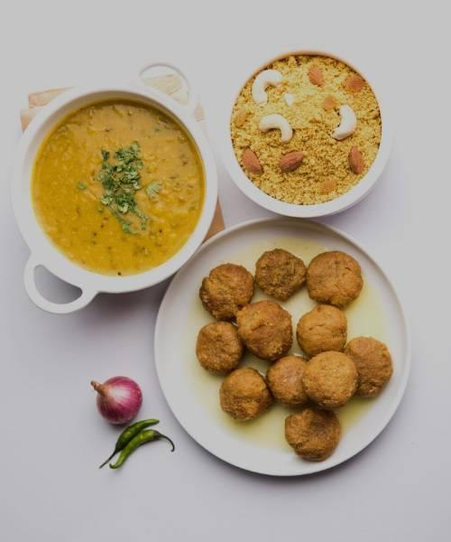
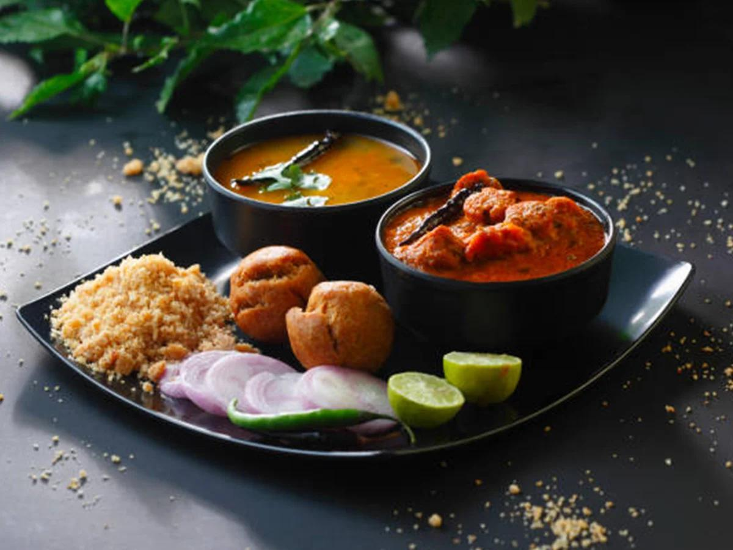
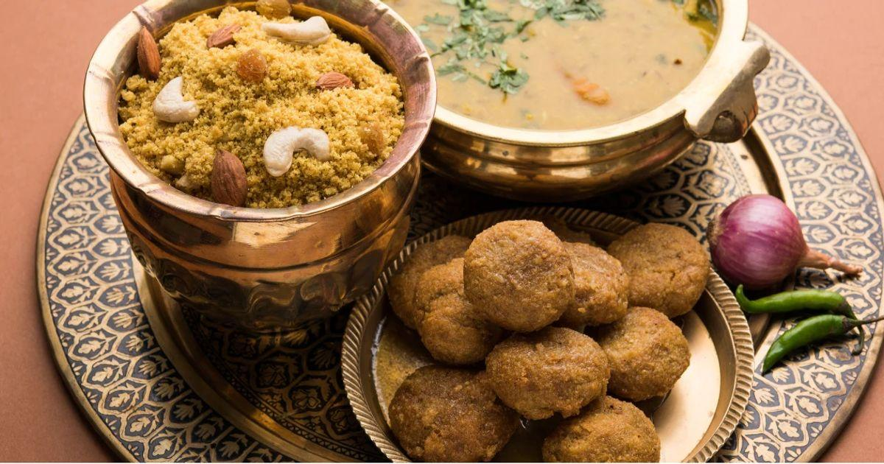

Luxury Experiences in Udaipur ✨
- Stay in lakefront heritage palaces
- Romantic rooftop candlelight dinners
- Private lake cruises
- Luxury spa experiences
- Heritage cultural evenings
- Vintage car tours
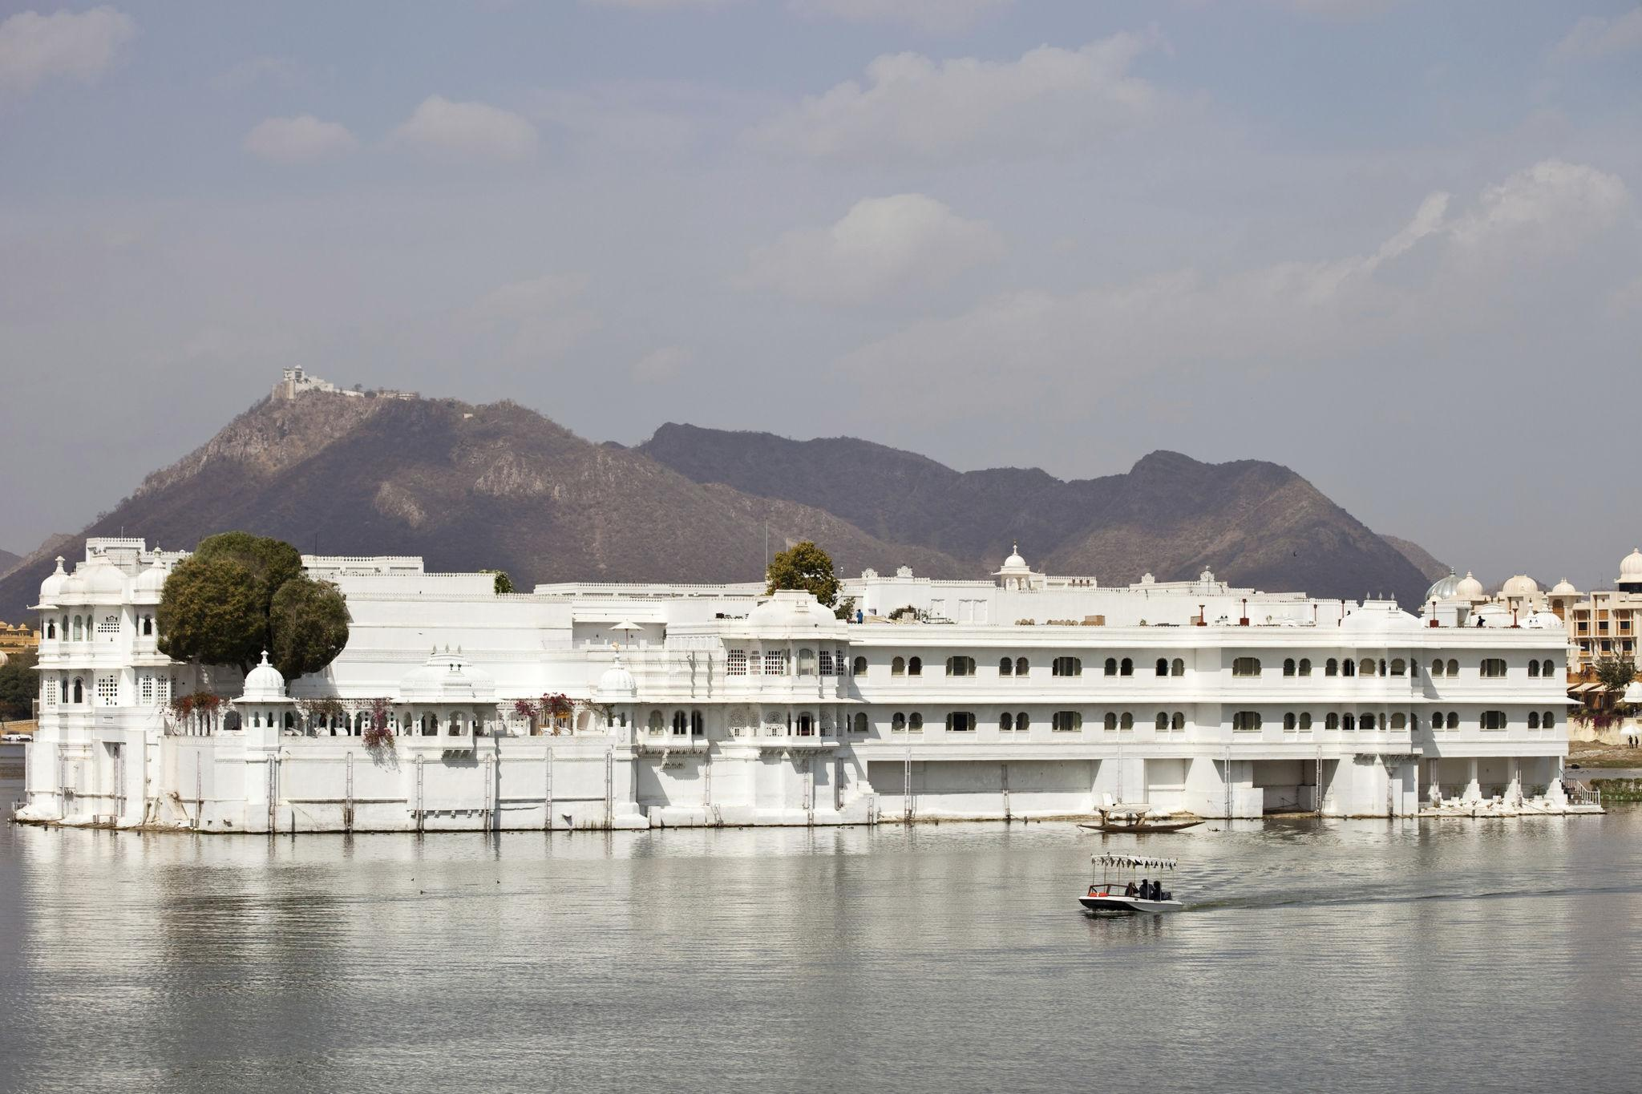

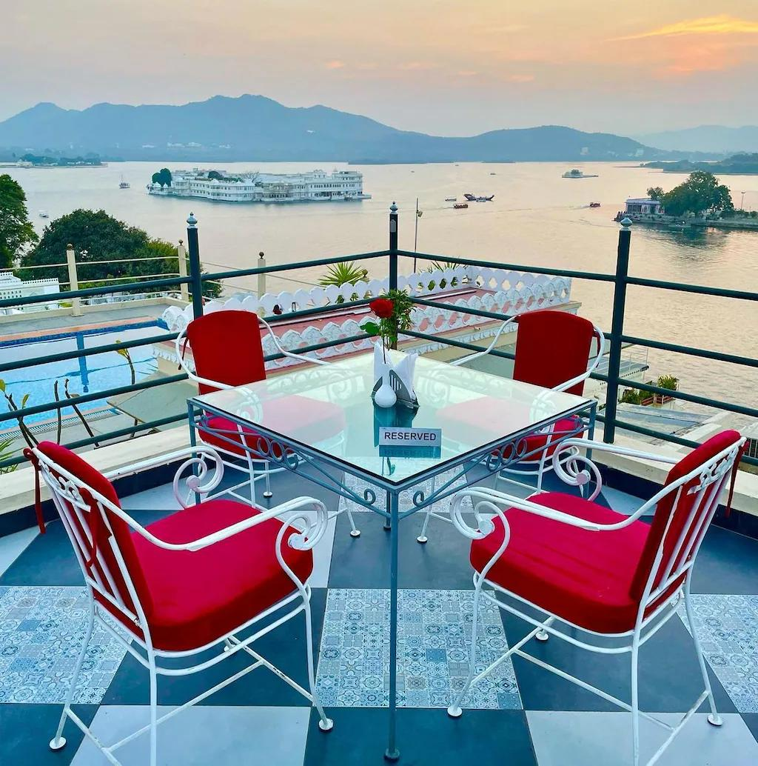
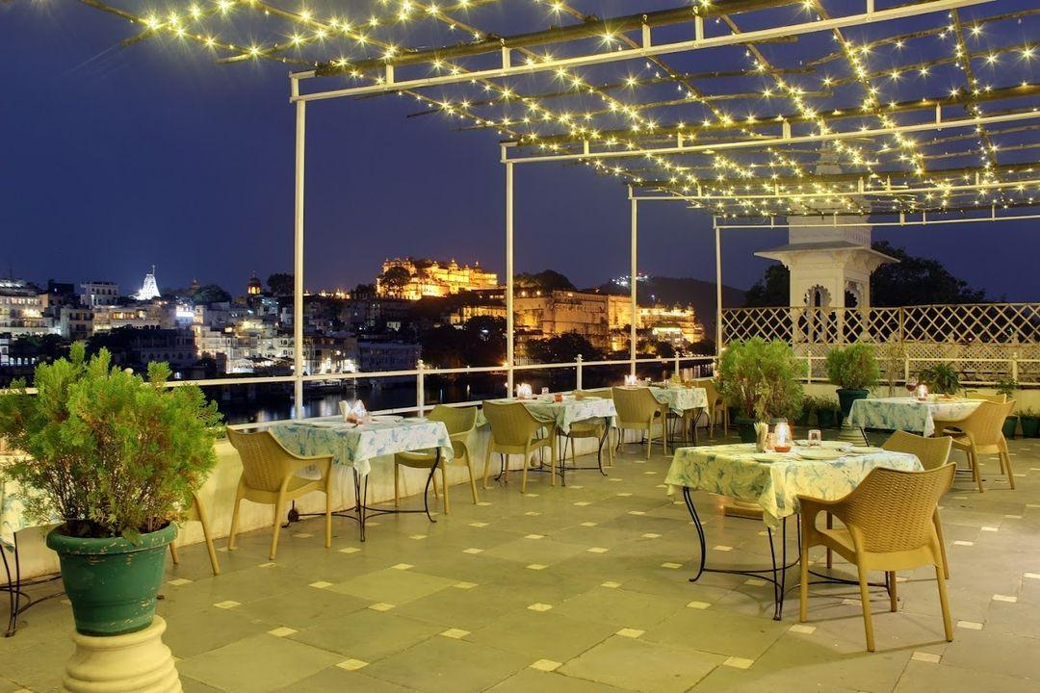
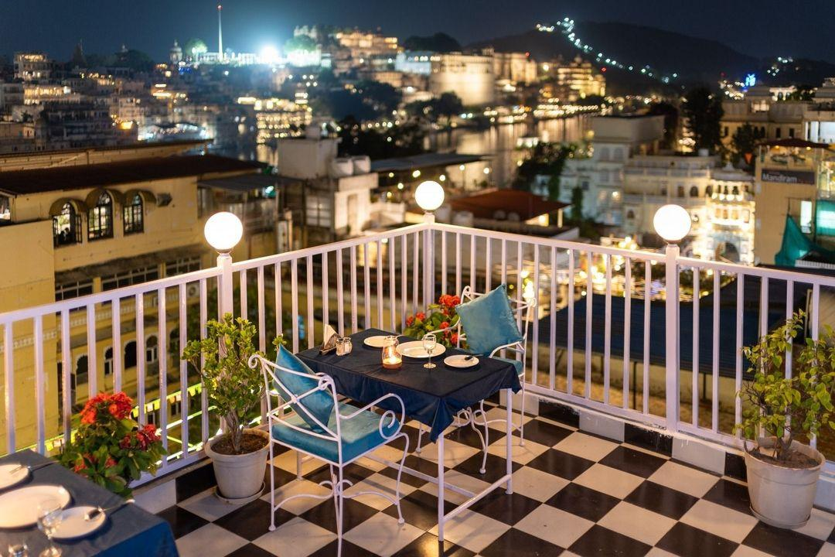
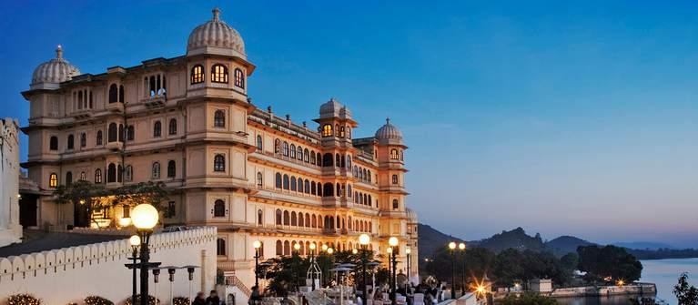
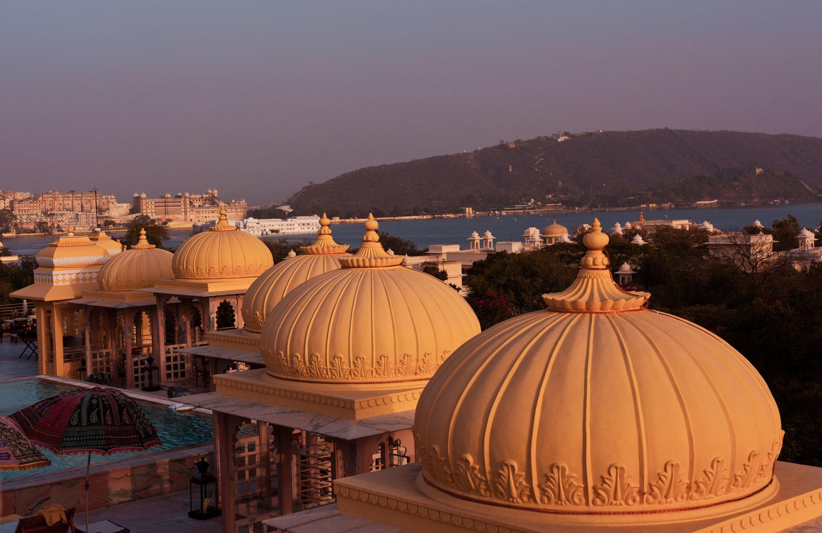

Udaipur Travel Tips
- Carry comfortable walking shoes
- Visit lakes during sunset hours
- Bargain politely in local markets
- Book heritage hotels early during peak season
- Carry light woolens during winter evenings
- Respect heritage monuments & local culture

Why Choose INTRO TRAVELS INDIA for Udaipur?
With INTRO TRAVELS INDIA, you get:
- Customized Udaipur holiday packages
- Heritage & honeymoon tours
- Luxury palace hotel stays
- Guided sightseeing tours
- Comfortable transport arrangements
- Family & group tours
- Cultural & shopping experiences
- Private lake cruise bookings
Udaipur is a destination where royal palaces, shimmering lakes, colorful culture, luxury experiences, and romantic charm come together to create one of India’s most unforgettable travel experiences.

